

**PROJECT REPORT ON**

***“College Blog”***

Submitted in partial fulfillment of the requirements for NoSQL Project

Lab for 5th Semester

Master of Computer Applications

Submitted by

***Aneesh Mathew 19CS801005***

***Jerin Joji 19cs801016***

Under the guidance of

**Prof. Ayshwarya B**



**CERTIFICATE**

This is to certify that the project titled ***“College Blog”*** has been satisfactorily completed by **Mr. JERIN JOJI** with **19CS801016**, in partial fulfillment of the requirements for ***NoSQL Databases Project Lab*** with course code **MCASP2A51,** for the Vth Semester MCA course during the academic semester from August 2021 to December 2021 as prescribed by Bangalore North University.

**Faculty In-charge Head of the Department**

**Valued by**

Examiner 1:_______________________ Date :

Examiner 2:_______________________ Centre: Kristu Jayanti College

**ACKNOWLEDGEMENT**

First of all, we would like to thank the God Almighty for all the blessings he has showered on us. Our spiritual quotient gave us more strength and motivation that helped immensely.

We would like to thank **Rev.** **Dr. Augustine George,** our Principal, for providing us his constant guidance and support. I would also like to thank **Rev. Fr. Lijo P Thomas,** our Financial Administrator, for providing us with the best facilities.

We are extremely thankful to our **Dr. R. Kumar**, Head, Department of Computer Science (PG) for giving us the essential support in the form of allocating comfortable lab hours and necessary resources.

We would like to extend our heartfelt thanks to **Prof. Ayshwarya B**, our project guide for providing us the necessary details related to project development and process identification enabling us to finish the project within the stipulated time.

We thank all other faculty members who helped us a lot in completing this project. The computer lab was always open for us. We thank the lab administrator and other technical staff for their help and support.

We thank our class mates, who have pointed out errors and guided us a lot and we thank each and every one who has helped us.

**Synopsis**

**Introduction**

A blog is a place to express yourself to the world. A place to share your thoughts and your passions. It can help in the promotion of critical and analytical thinking, increased access and exposure to quality content, and a combination of solitary and social interactions with peers. Currently, students in schools or colleges are unable to express their ideas, their talent, or anything that can be expressed for some benefit for everyone. College blog is a perfect platform for students, teachers, and institutional administrative purposes to promote collaboration between students and teachers. It increases motivation for reading and writing and showcases the student’s accomplishments, talents, ideas, or anything that they can’t express.

**Definition of the System**

The Online Blogging System will allow the users to publish the writings, videos, images, or audios if he/she should have credentials to log in. The main users of this project are students, teachers and administrators.

**List of Modules**

* Login/Registration, Write New Blog, Read Blog, Edit Blog, Delete Blog, Update User Account, View Blog, Search Blog

**CONTENTS**

|  |  |  |
| --- | --- | --- |
| **SI.NO**  **1.**  **2.**  **3.**  **4.**  **5.**  **6.**  **7.**  **8.**  **9.**  **10.**  **11.** | **Description**  **Introduction**   * **Problem Definition** * **Project Description**   **System Study**  **2.1 Existing System**  **2.2 Proposed System**  **2.3 Use Case Diagram**  **2.4 Activity Diagram**  **System Configuration**  **3.1 Hardware Configuration**  **3.2 Software Configuration**  **Details of Software**  **4.1 Overview of Front End**  **4.2 Overview of Back End**  **System Design**  **5.1 Architectural Design**  **5.2 Input Design**  **5.3 Output Design**  **5.4 Database Design**  **Source Code**  **Testing**  **Implementation**  **Screen Shot**  **Conclusion**  **Bibliography** | **Pg. No**  7  8  9  9  10  11-13  14  14  15  16  17  18-23  24-26  27-28  29-68  69  70  71-73  74-77  78  79 |

**Introduction**

**Project Definition**

A blog is a place to express yourself to the world. A place to share your thoughts and your passions. It can help in the promotion of critical and analytical thinking, increased access and exposure to quality content, and a combination of solitary and social interactions with peers. Currently, students in schools or colleges are unable to express their ideas, their talent, or anything that can be expressed for some benefit for everyone. College blog is a perfect platform for students, teachers, and institutional administrative purposes to promote collaboration between students and teachers. It increases motivation for reading and writing and showcases the student’s accomplishments, talents, ideas, or anything that they can’t express.

**Project Description**

The College Blog will allow the users to publish the writings, videos, images, or audios if he/she should have credentials to log in. The main users of this project are students, teachers and administrators. The users of this website can read and search any blogs they would like to read and sort the blogs according to their title, categories, etc. The users can also write a blog adding with pictures and also like and comment on other users’ blog.

We have only one actor playing role in this system that is **Users**.

The module for users are:

* **Login/Registration** – The new users of this website has to register to the website to read the blogs. The existing users has to login to read the blogs. Validations are added to the register page like existing emails not allowed.
* **View Blog** – The Users can view all the blogs present in the database along with their name, author and a small description.
* **Search Blog** – The users can search specific blogs based on the keyword given. It can search based on title, authors or categories.
* **Write New Blog** – The users can write new blogs by writing the title and content with a small description and references.
* **Read Blog** – The user can see the other blogs title, author and small description of the blog and also read the whole blog.
* **Edit Blog** – The user can edit their own blogs if they want to.
* **Delete Blog** – The user can delete their own blog if they want to.
* **Update User Account** – The user can edit their own profile and add other details.

**System Study**

**Existing System**

Colleges today needs to give students a platform where students and express their thoughts, passion and research. It can help in the promotion of critical and analytical thinking, increased access and exposure to quality content, and a combination of solitary and social interactions with peers. Currently, students in schools or colleges do not have any specific platform to express their ideas, their talent, or anything that can be expressed for some benefit for everyone. So, we thought of giving students a platform where students can express their thoughts, ideas, talent, etc.

**Proposed System**

College blog is a perfect platform for students, teachers, and institutional administrative purposes to promote collaboration between students and teachers. It increases motivation for reading and writing and showcases the student’s accomplishments, talents, ideas, or anything that they can’t express. It will allow the users to publish the writings, videos, images, or audios if he/she should have credentials to log in. The users of this website can read and search any blogs they would like to read and sort the blogs according to their title, categories, etc. The users can also write a blog adding with pictures and also like and comment on other users’ blog.

**Use Case Diagram**

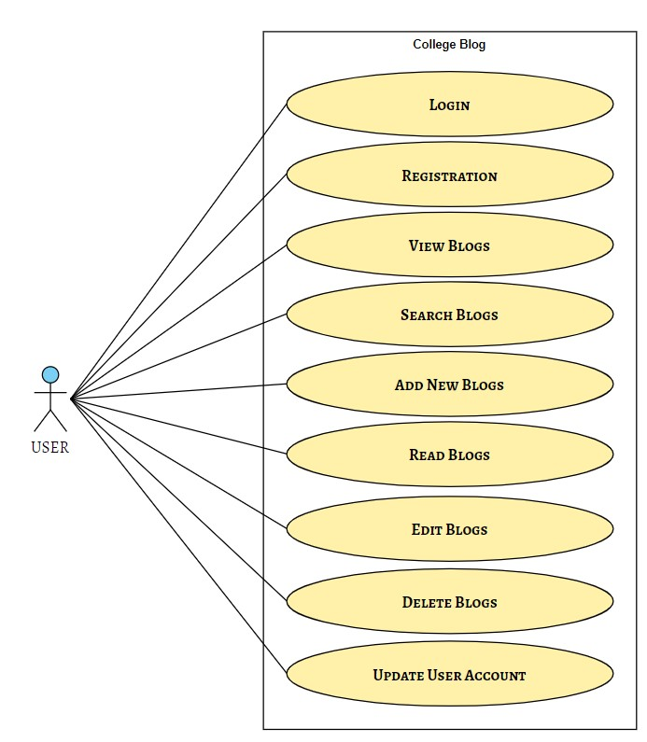

**Activity Diagram**

***Login / Registration – Activity Diagram***

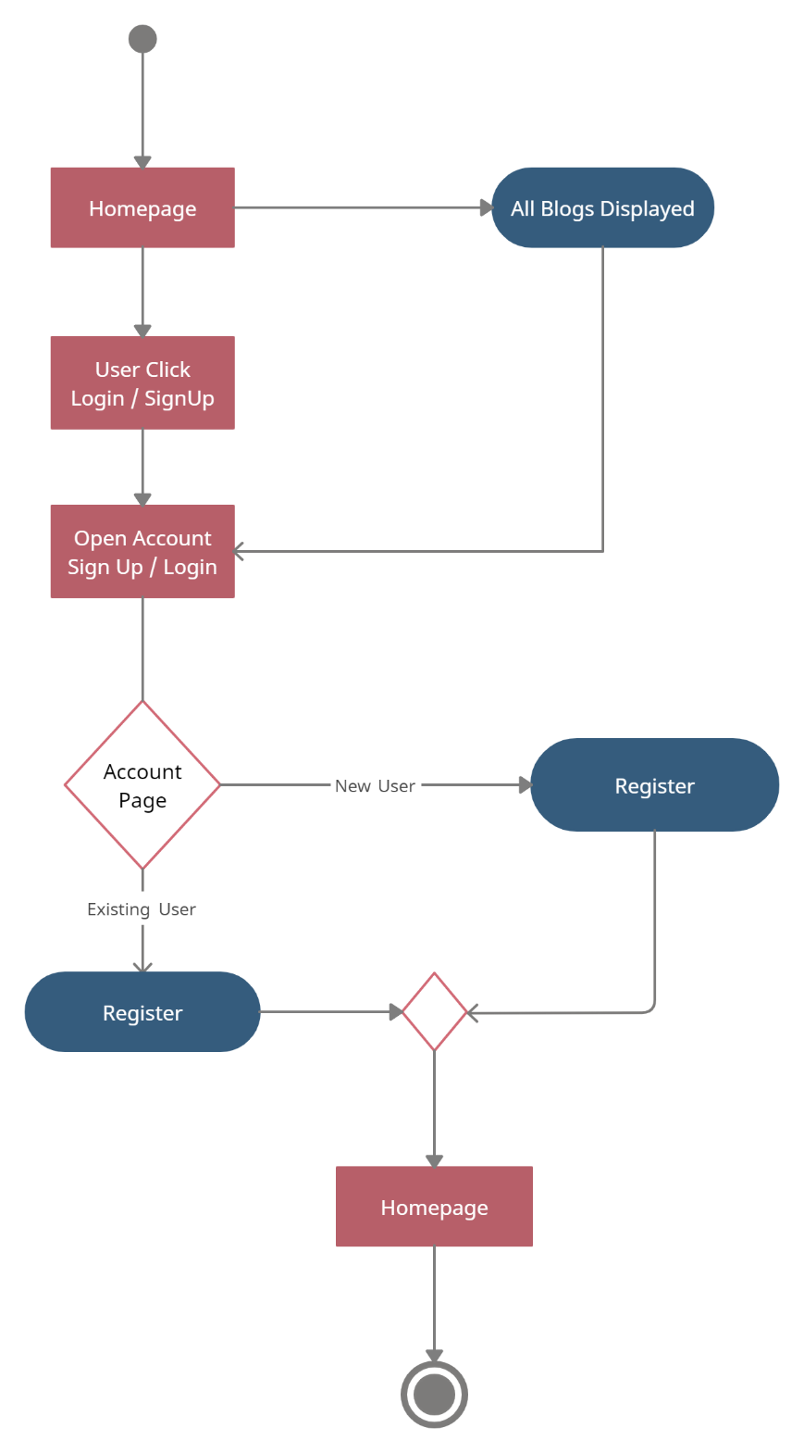

***Homepage and Read Blog – Activity Diagram***

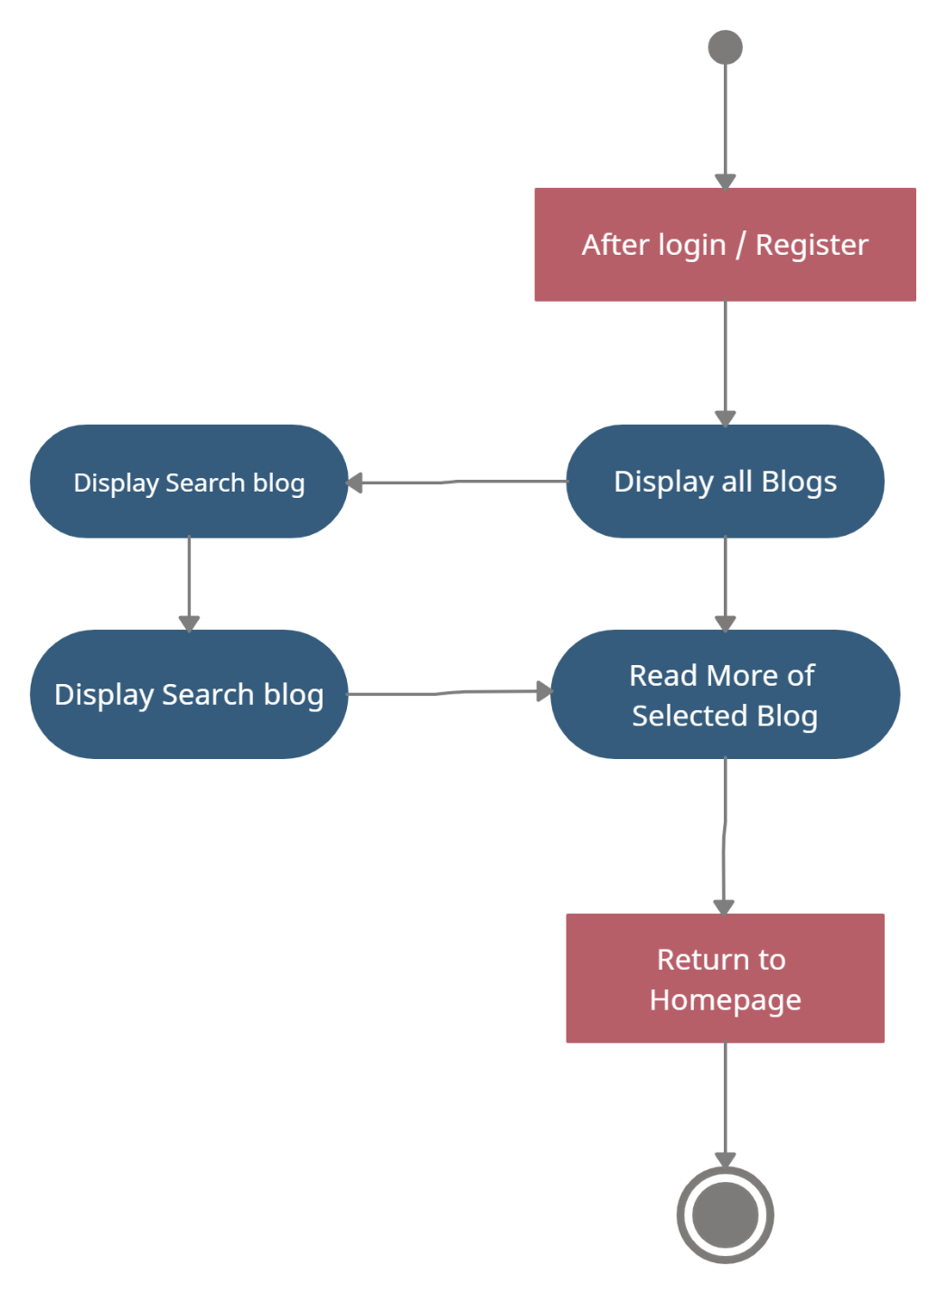

***Add New Blog – Activity Diagram***

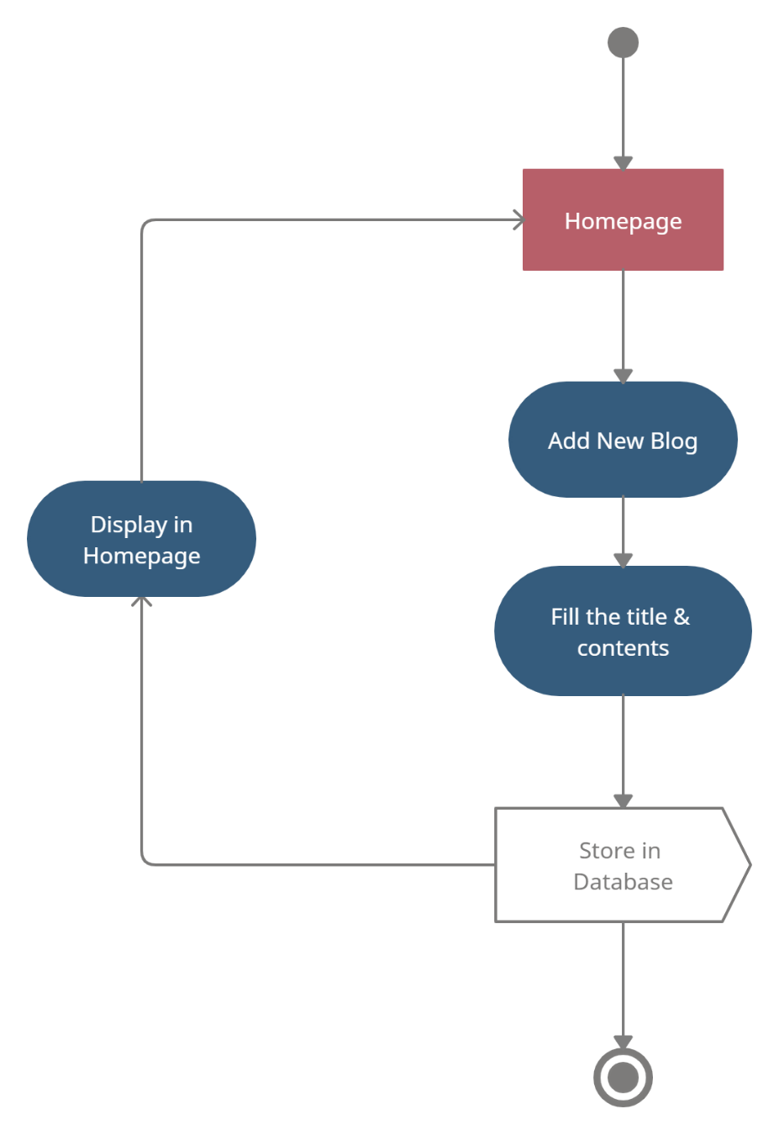

**System Configuration**

**Hardware Configuration**

|  |  |
| --- | --- |
| **RAM** | 8 GB |
| **Hard Disk** | 1TB |
| **Processor** | Intel i5 Core |
| **Keyboard** | Lenovo Legion Keyboard |
| **Mouse** | Logitech Mouse |

**Software Configuration**

|  |  |
| --- | --- |
| **Operating System** | Windows 11 |
| **Front-End** | Html, CSS, JavaScript, React |
| **Back-End** | Python, Flask, MongoDB |
| **Tools** | VSCode, MongoCompass, Git |
| **Documentation Tools** | MS Word 2013 |

**Details of Software**

**Overview of Front End**

For the front-end design, we used **HTML, CSS, JavaScript and React** to build our view of the system. We used many types of tags with their attributes and CSS attached to them each for our many different views. We used: -

* **<h1> to <h6>** - To displaying headings
* **<p>** - To display the text
* **<a>** - To put a hyperlink
* **<form>** - To create user forms
* **<input type = text, number, date, email, submit>** - To display various inputs each with a type of input.
* **<div>** - To divide and create partitions
* **<img>** - To display images
* **<li>** - To display list
* **<hr>** - To display a horizontal line

And many more tags and attributes which can can make the view of the system more and more user friendly.

**Overview of Back End**

When we completed the work on frontend it was time to put some actions and make the system working by working on its back-end. We used **Flask and Python** as the the language to make the system into a working system. We thought that Python can be a better language to interact with the server and get the job done. We also needed a database to store the data and to fetch the necessary data when required. So, we used **MongoDB** as a tool for storing the data and fetching it.

In Flask, we used **pymongo** in python which can help with fetching and inserting the data in MongoDB. For connecting python with MongoDB, we need the connection string of MongoDB that is **localhost:27017.**

We also used many imports for making this website. The imports are Flask, Response, request, session, redirect, url_for, render_template, flash.

* bcrypt==3.2.0
* Flask==2.0.1
* Flask-Bcrypt==0.7.1
* Jinja2==3.0.1
* passlib==1.7.4
* pycparser==2.20
* pymongo==3.12.0

**System Design**

**Architectural Design**

Our system architecture is a very simple MongoDB and Flask architecture which contains a web browser which displayed the view of the system, and the flask which contains the model and the view of the system and a data store which stores the data. The model contains the data which was fetched from the database and the view contains the user interface of how the system should look.

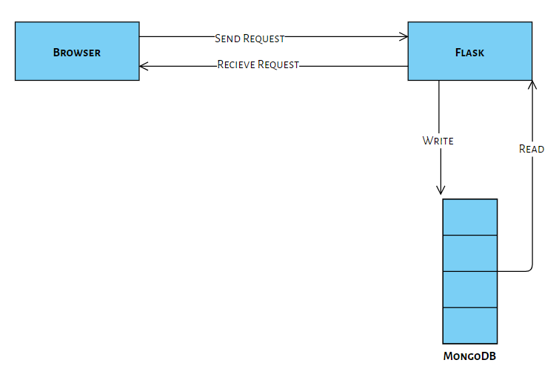

**Input Design**

The inputs taken in this system is a way to know the actions required and requested by the user or the admin. The inputs taken in this system are: -

***Registration***

Users can register to the website and create an account for themselves by sharing some of the personal information like name, email and password. This information is provided to the system in a form. Also, validations are added in the form so that form be filled in correct format and also if the account exist or not by the email given.

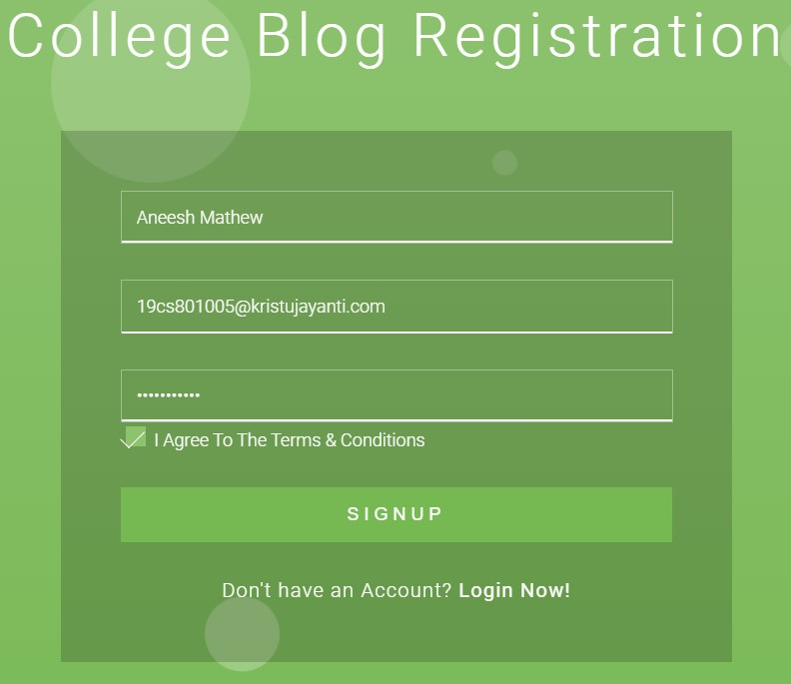

***Login User***

If a user already has an account in the system, he/she could login to the system by providing the email and password. This information is provided to the system in a form. Validations are set up to check if an account exists or to check the password and email are correct or not.

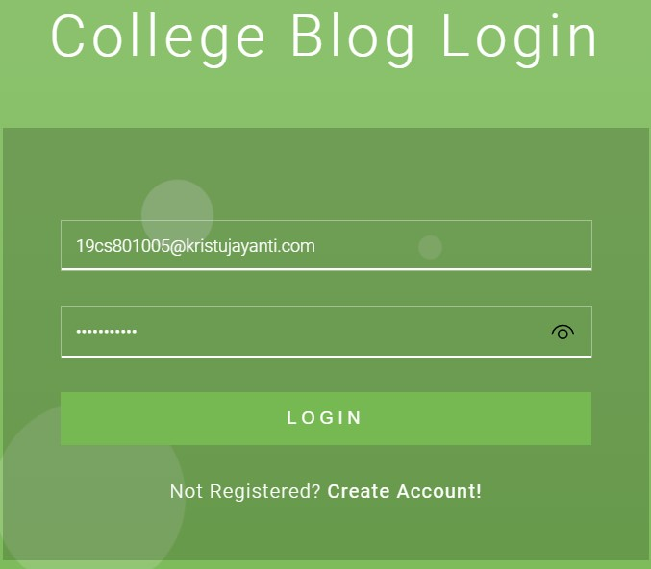

***Write New Blog***

The user gets the option of writing and adding his own blog. The information taken for writing and adding the blog are Title of the blog, author, small description, reference link and contents.

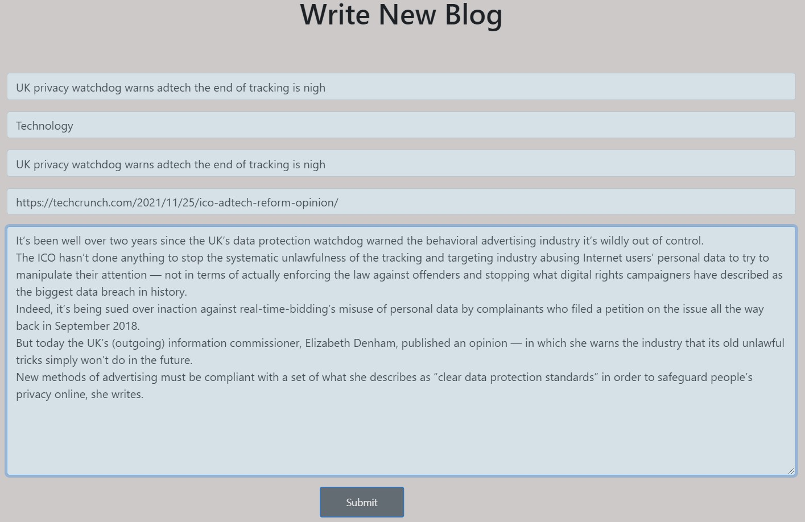

***Search Blog***

This input takes information and helps user to find blogs based on their title, authors, description, references, etc. This information is provided to the system in the form of an input textbox and a button.

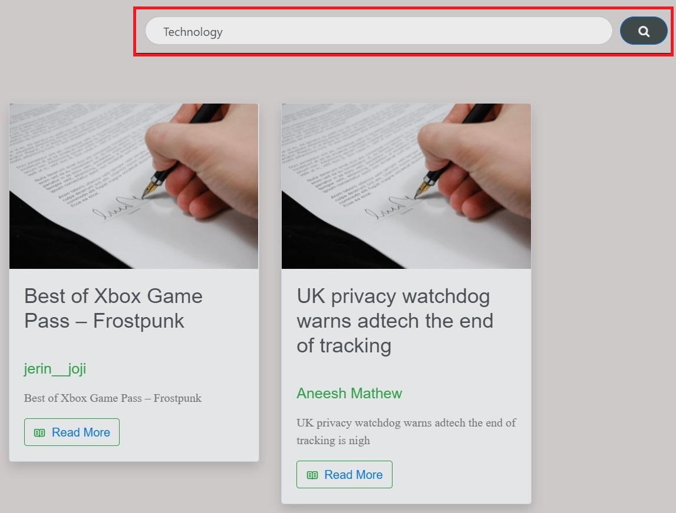

***Read More***

This input takes information about the blog which needs to be read more by the user. This information is provided to the system in the form of a button.

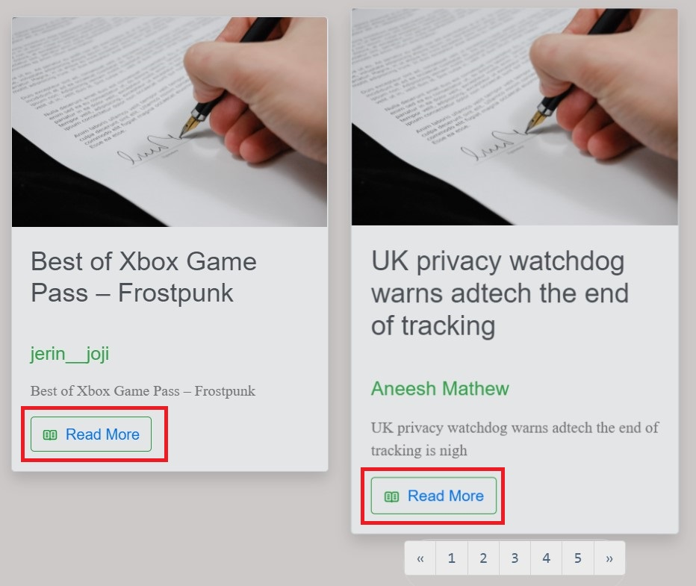

***Like/Comment***

This input takes the comments of the user for the specific blog. The comment information is provided to the system in the form of a textbox and a button and the like information is provided through a button.

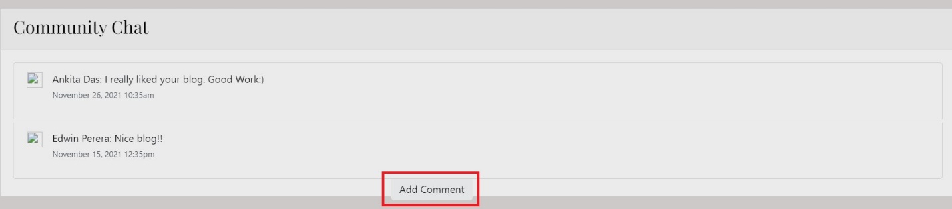

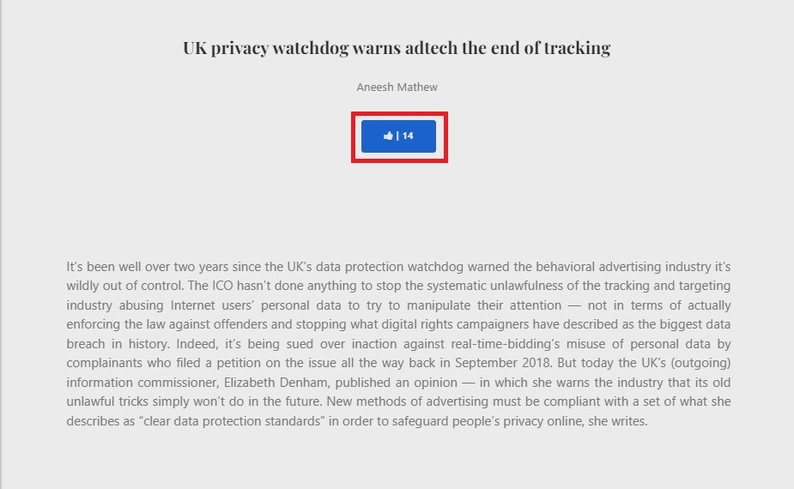

***Logout***

This input takes the user outside his/her account and returns to homepage. This information is provided to the system in the form of a button.

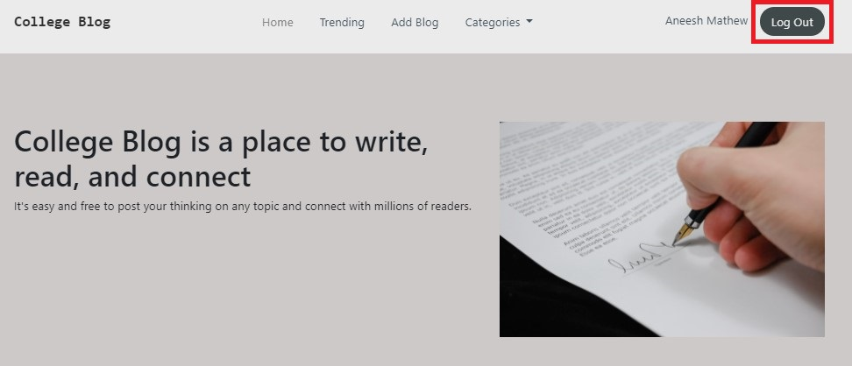

**Output Design**

The outputs shown in the system is a way of showing the results which is generated by the inputs given by the user. The outputs shown in the system are: -

***All Blog***

This output shows the user about all the blogs which are there for users to read. This output shows the title, author and small description. This output is shown in a form a list.

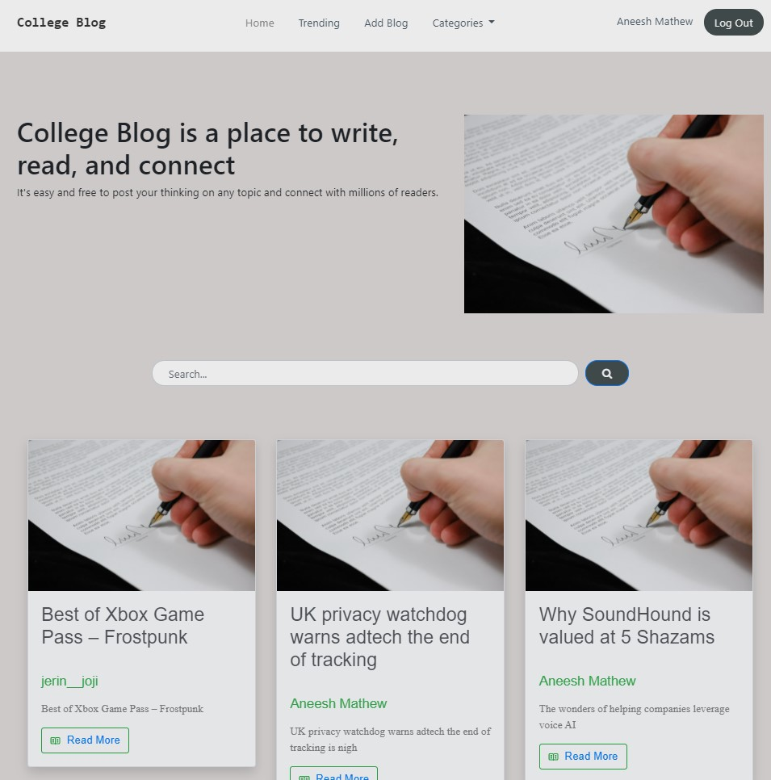

***Read Blog***

This output shows the user the content of the selected blog like title, author and contents. This output is shown in a form of a paragraph.

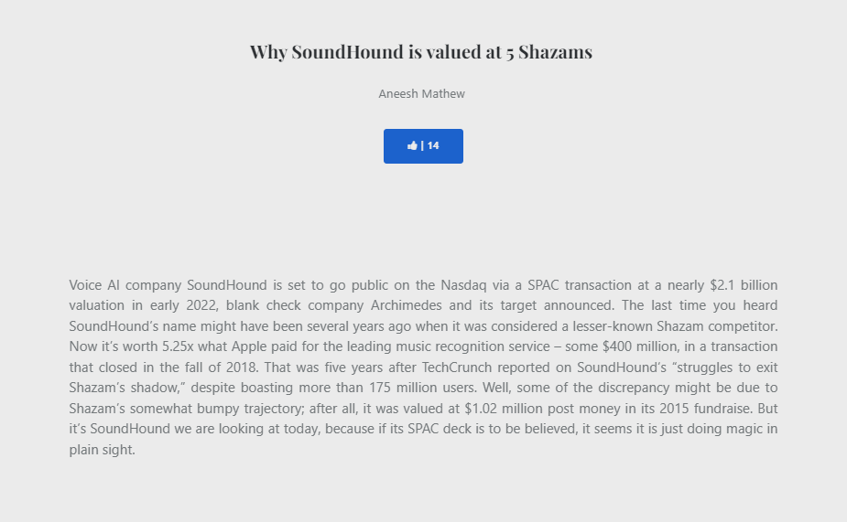

***Comment section***

This output shows the user all the comment of the selected blog written by other. This output is shown in a form of a list.

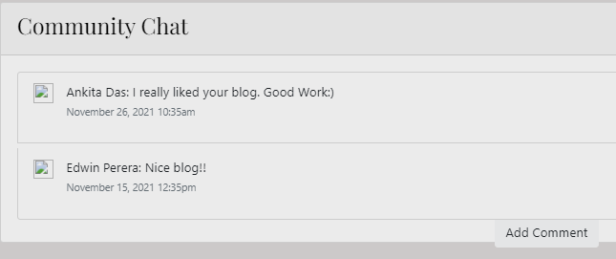

***Search Result***

This output shows the user the results of the search they made based based on their title, authors, description, references, etc. The display shows the blog title, author and small description. This output is shown in a form a list.

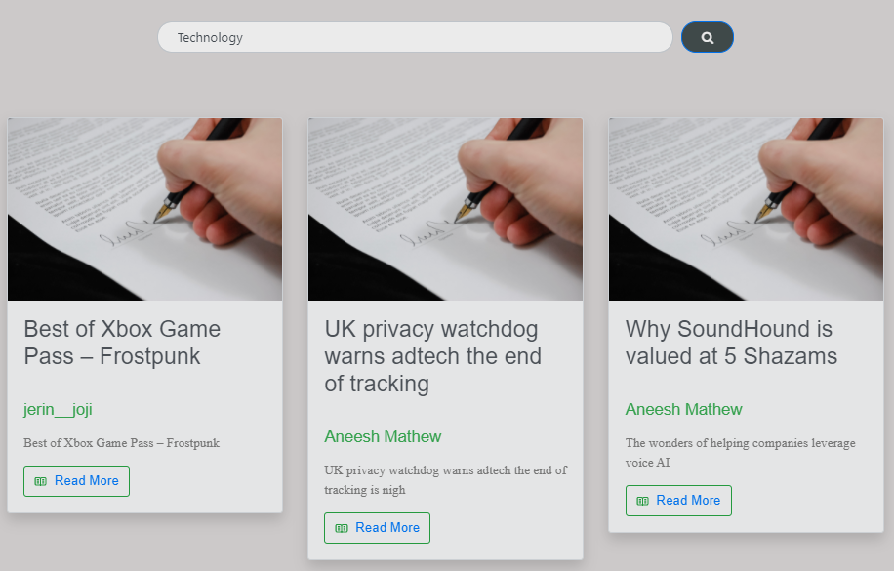

**Database Design**

Database is used to store the data and records. A good database design can help the system and the developer to understand, insert and fetch the data or records in an easy and efficient manner. The databases used in this system are: -

***Student Database*** - This database is used to store all the details required for the system related to books.

|  |  |
| --- | --- |
| **Column** | **DataType** |
| _id | ObjectId |
| username | varchar |
| email | varchar |
| password | varchar |

***Blog Database*** – This database is used to store all the blogs entered by the users.

|  |  |
| --- | --- |
| **Column** | **Data Type** |
| _id | ObjectId |
| Student_id | integer |
| author | varchar |
| title | varchar |
| category | varchar |
| smalldesc | varchar |
| reflink | varchar |
| content | varchar |
| likes | integer |

**Source Code**

**app.py**

import re

from flask import Flask, Response, request, session, redirect, url_for, render_template, flash

import json

import pymongo

from bson.objectid import ObjectId

app = Flask(__name__)

app.secret_key = "jerin"

########Connection##########

try:

mongo = pymongo.MongoClient(

host='localhost',

port=27017,

serverSelectionTimeoutMS=1000

)

db = mongo.blog

mongo.server_info()

except:

print ("Error - Couldn't connect to Mongo'")

########Connection##########

@app.route("/homepage")

def homepage():

blog = db.blogs.find({})

return render_template('index.html', blog=blog)

@app.route("/registerpage")

def registerpage():

return render_template('register.html')

@app.route("/loginpage")

def loginpage():

return render_template('login.html')

@app.route("/newblog")

def newblog():

return render_template('newpost.html')

@app.route("/viewblog")

def viewblog():

if not session.get('logged'):

return redirect(url_for('loginpage'))

else:

myvar = request.args.get('myvar', '')

blog = db.blogs.find({'_id' : ObjectId(myvar)})

return render_template('viewblog.html', blog=blog)

@app.route("/search", methods=['GET', 'POST'])

def search():

search = db.blogs.find({"$or":[ {"author": {"$regex": request.form['search']}}, {"title": {"$regex": request.form['search']}}, {"category":request.form['search']}]})

return render_template('search.html', search = search)

@app.route("/logout")

def logout():

session.pop('username',None)

session.pop('email',None)

session.pop('id',None)

session.pop('logged',None)

blog = db.blogs.find({})

return render_template('index.html', blog=blog)

########Registration#########

@app.route("/register", methods=['GET', 'POST'])

def register():

if request.method == 'POST':

users = db.students

existing_user = users.find_one({'email' : request.form['email']})

if existing_user is None:

users.insert_one({'username': request.form['username'], 'email' : request.form['email'], 'password' : request.form['password']})

data = list(users.find({'email' : request.form['email']}))

for user in data:

user["_id"] = str(user["_id"])

session['id'] = user["_id"]

session['email'] = request.form['email']

session['username'] = request.form['username']

session['logged'] = 'TRUE'

return redirect(url_for("homepage"))

else:

flash('Email Already Exists')

return render_template('register.html')

return redirect(url_for("registerpage"))

########Registration#########

########Login#########

@app.route('/login', methods=['GET', 'POST'])

def login():

if request.method == 'POST':

login_stud = db.students.find_one({'email' : request.form['email'], 'password' : request.form['password']})

if login_stud:

data = list(db.students.find({'email' : request.form['email']}))

for user in data:

user["_id"] = str(user["_id"])

session['username'] = user["username"]

session['id'] = user["_id"]

session['email'] = request.form['email']

session['logged'] = 'TRUE'

return redirect(url_for("homepage"))

else:

flash('Invalid Email/Password')

return redirect(url_for("loginpage"))

########Login#########

########New Blog Post#########

@app.route('/newpost', methods=['GET', 'POST'])

def newpost():

if request.method == 'POST':

blog = db.blogs

blog.insert_one({'student_id': session['id'], 'author': session['username'], 'title' : request.form['title'], 'category' : request.form['category'], 'smalldesc' : request.form['smalldesc'], 'reflink' : request.form['reflink'],'content' : request.form['content'], 'likes': 0})

return redirect(url_for("homepage"))

return redirect(url_for("newblog"))

########New Blog Post#########

if __name__ == '__main__':

app.run(debug=True)

**index.html**

<!DOCTYPE html>

<html lang="en">

<head>

<meta charset="utf-8">

<meta name="viewport" content="width=device-width, initial-scale=1.0, shrink-to-fit=no">

<title>College Blog | Homepage</title>

<link rel="stylesheet" href="static/assets/bootstrap/css/bootstrap.min.css">

<link rel="stylesheet" href="https://fonts.googleapis.com/css?family=ABeeZee">

<link rel="stylesheet" href="https://fonts.googleapis.com/css?family=Abhaya+Libre&amp;display=swap">

<link rel="stylesheet" href="static/assets/fonts/font-awesome.min.css">

<link rel="stylesheet" href="static/assets/fonts/ionicons.min.css">

<link rel="stylesheet" href="static/assets/css/card-3-column-animation-shadows-images.css">

<link rel="stylesheet" href="static/assets/css/dh-card-image-left-dark.css">

<link rel="stylesheet" href="static/assets/css/dh-row-titile-text-image-right-1.css">

<link rel="stylesheet" href="static/assets/css/Footer-Dark.css">

<link rel="stylesheet" href="https://cdnjs.cloudflare.com/ajax/libs/animate.css/3.5.2/animate.min.css">

<link rel="stylesheet" href="https://cdnjs.cloudflare.com/ajax/libs/aos/2.3.4/aos.css">

<link rel="stylesheet" href="static/assets/css/Navigation-with-Button.css">

<link rel="stylesheet" href="static/assets/css/Responsive-footer-1.css">

<link rel="stylesheet" href="static/assets/css/Responsive-footer.css">

<link rel="stylesheet" href="static/assets/css/styles.css">

</head>

<body class="justify-content-around align-items-center align-content-center" style="background: rgb(204,201,201);filter: brightness(92%);border-color: rgb(195,210,225);">

<section>

<nav class="navbar navbar-light navbar-expand-md navigation-clean-button" data-aos="flip-up">

<div class="container"><a class="navbar-brand text-monospace d-inline-flex d-xl-flex flex-row flex-grow-1 flex-shrink-1 align-items-start align-content-start align-self-start my-auto justify-content-xl-start flash animated" href="/homepage" style="font-family: 'Abhaya Libre', serif;">College Blog&nbsp;</a><button data-toggle="collapse" class="navbar-toggler" data-target="#navcol-1"><span class="sr-only">Toggle navigation</span><span class="navbar-toggler-icon"></span></button>

<div class="collapse navbar-collapse" id="navcol-1">

<ul class="navbar-nav mr-auto">

<li class="nav-item"><a class="nav-link active" href="/homepage">Home</a></li>

<li class="nav-item"><a class="nav-link" href="#">Trending</a></li>

{% if session['email'] %}

<li class="nav-item"><a class="nav-link" href="/newblog">Add Blog</a></li>

{% endif %}

<li class="nav-item dropdown"><a class="dropdown-toggle nav-link" aria-expanded="false" data-toggle="dropdown" href="#">Categories&nbsp;</a>

<div class="dropdown-menu"><a class="dropdown-item" href="#">Tech</a><a class="dropdown-item" href="#">Economy</a><a class="dropdown-item" href="#">Lifestyle</a></div>

</li>

</ul>

{% if session['email'] %}

<span class="navbar-text actions"> <a class="login" href="">{{session['username']}}</a><a class="btn btn-light action-button" role="button" href="/logout" style="background: rgb(68,79,79);">Log Out</a></span>

{% else %}

<span class="navbar-text actions"> <a class="login" href="/loginpage">Log In</a><a class="btn btn-light action-button" role="button" href="/registerpage" style="background: rgb(68,79,79);">Sign Up</a></span>

{% endif %}

</div>

</div>

</nav>

</section><br><br><br>

<div id="empresa" style="padding:20px;margin:1px;">

<div class="container">

<div class="row">

<div class="col-sm-6 col-md-7 col-lg-7">

<h1>College Blog is a place to write, read, and connect<br></h1>

<p>It's easy and free to post your thinking on any topic and connect with millions of readers.<br></p>

</div>

<div class="col-sm-6 col-md-5 col-lg-5"><img src="static/assets/img/law-document.jpeg"></div>

</div>

</div>

</div>

<section>

<div class="container bounce animated pb-5 pt-5">

<div class="col-md-9 col-xl-8 ml-auto mr-auto">

<form action="{{url_for('search')}}" method="post">

<div class="align-items-center form-row">

<div class="form-group col-sm"><input class="form-control form-control pl-4 pr-4 rounded-pill" type="text" name="search" placeholder="Search..."></div>

<div class="form-group col-sm-auto text-right"><button class="btn btn-primary pl-4 pr-4 rounded-pill" type="submit" style="background: rgb(68,79,79);"><i class="fa fa-search"></i></button></div>

</div>

</form>

</div>

</div>

<div class="container">

<div class="row">

<div class="col">

<section>

<div class="container">

<div class="row">

{% for data in blog %}

<div class="col-auto col-sm-12 col-md-12 col-lg-4 col-xl-4" style="padding-top: 15px;padding-bottom: 15px;padding-right: 15px;padding-left: 15px;">

<div class="bg-light border rounded shadow card" data-bss-hover-animate="pulse"><img class="card-img-top" src="static/assets/img/law-document.jpeg">

<div class="card-body">

<h3 class="card-title" style="font-family: Antic, sans-serif;color: rgb(81,87,94);">{{data.title}}</h3>&nbsp;</h3>

<h5 class="card-sub-title" style="font-family: Antic, sans-serif;color: #38ae53;">{{data.author}}</h5>

<p class="card-text" style="font-family: Antic, sans-serif;color: rgb(81,87,94);"></p><p id="lorem"> {{data.smalldesc}}</p>

<button onclick="" class="btn btn-outline-success" type="button" style="font-weight: normal;font-family: Antic, sans-serif;"><svg xmlns="http://www.w3.org/2000/svg" width="1em" height="1em" viewBox="0 0 24 24" fill="none">

<path fill-rule="evenodd" clip-rule="evenodd" d="M4 5.5H9C10.1046 5.5 11 6.39543 11 7.5V16.5C11 17.0523 10.5523 17.5 10 17.5H4C3.44772 17.5 3 17.0523 3 16.5V6.5C3 5.94772 3.44772 5.5 4 5.5ZM14 19.5C13.6494 19.5 13.3128 19.4398 13 19.3293V19.5C13 20.0523 12.5523 20.5 12 20.5C11.4477 20.5 11 20.0523 11 19.5V19.3293C10.6872 19.4398 10.3506 19.5 10 19.5H4C2.34315 19.5 1 18.1569 1 16.5V6.5C1 4.84315 2.34315 3.5 4 3.5H9C10.1947 3.5 11.2671 4.02376 12 4.85418C12.7329 4.02376 13.8053 3.5 15 3.5H20C21.6569 3.5 23 4.84315 23 6.5V16.5C23 18.1569 21.6569 19.5 20 19.5H14ZM13 7.5V16.5C13 17.0523 13.4477 17.5 14 17.5H20C20.5523 17.5 21 17.0523 21 16.5V6.5C21 5.94772 20.5523 5.5 20 5.5H15C13.8954 5.5 13 6.39543 13 7.5ZM5 7.5H9V9.5H5V7.5ZM15 7.5H19V9.5H15V7.5ZM19 10.5H15V12.5H19V10.5ZM5 10.5H9V12.5H5V10.5ZM19 13.5H15V15.5H19V13.5ZM5 13.5H9V15.5H5V13.5Z" fill="currentColor"></path>

</svg>&nbsp;<a href="{{url_for('viewblog', myvar=data._id)}}" style="text-decoration:none;"> Read More</a></button>

</div>

</div>

</div>

{% endfor %}

</div>

</div>

</section>

</div>

</div>

</div>

<center>

<div class="row">

<div class="col-lg-12 offset-lg-0 align-self-center" style="filter: sepia(4%);transform-origin: center;">

<nav class="text-monospace border rounded-pill d-inline-flex align-items-center align-content-center align-self-center" style="filter: grayscale(76%) invert(0%);">

<ul class="pagination">

<li class="page-item"><a class="page-link" href="#" aria-label="Previous"><span aria-hidden="true">«</span></a></li>

<li class="page-item"><a class="page-link" href="#">1</a></li>

<li class="page-item"><a class="page-link" href="#">2</a></li>

<li class="page-item"><a class="page-link" href="#">3</a></li>

<li class="page-item"><a class="page-link" href="#">4</a></li>

<li class="page-item"><a class="page-link" href="#">5</a></li>

<li class="page-item"><a class="page-link" href="#" aria-label="Next"><span aria-hidden="true">»</span></a></li>

</ul>

</nav>

</div>

</center>

</div>

</section>

<section>

<footer class="footer-dark">

<div class="container">

<div class="row">

<div class="col-sm-6 col-md-3 item">

<h3>Services</h3>

<ul>

<li><a href="#">_______</a></li>

<li><a href="#">--------</a></li>

<li><a href="#">######</a></li>

</ul>

</div>

<div class="col-sm-6 col-md-3 item">

<h3>About</h3>

<ul>

<li><a href="#">(()()()()</a></li>

<li><a href="#">21651651</a></li>

<li><a href="#">-5159811</a></li>

</ul>

</div>

<div class="col-md-6 item text">

<h3>Company Name</h3>

<p>Add a class of&nbsp;fa-fw&nbsp;on the HTML element referencing your icon to set one or more icons to the same fixed width. This is great to use when varying icon widths&nbsp;<br></p>

</div>

<div class="col item social"><a href="#"><i class="icon ion-social-facebook"></i></a><a href="#"><i class="icon ion-social-twitter"></i></a><a href="#"><i class="icon ion-social-wordpress-outline"></i></a><a href="#"><i class="icon ion-social-instagram"></i></a></div>

</div>

<p class="copyright">KJC_College Blog © 2021</p>

</div>

</footer>

</section>

<script src="static/assets/js/jquery.min.js"></script>

<script src="static/assets/bootstrap/js/bootstrap.min.js"></script>

<script src="static/assets/js/bs-init.js"></script>

<script src="https://cdnjs.cloudflare.com/ajax/libs/aos/2.3.4/aos.js"></script>

</body>

</html>

**Login.html**

<!DOCTYPE html>

<html>

<head>

<title>College Blog Login</title>

<meta name="viewport" content="width=device-width, initial-scale=1">

<meta http-equiv="Content-Type" content="text/html; charset=utf-8" />

<script type="application/x-javascript">

addEventListener("load", function() {

setTimeout(hideURLbar, 0);

}, false);

function hideURLbar() {

window.scrollTo(0, 1);

}

</script>

<link href="static/registerstyle.css" rel="stylesheet" type="text/css" media="all" />

<link href="//fonts.googleapis.com/css?family=Roboto:300,300i,400,400i,700,700i" rel="stylesheet">

</head>

<body>

<div class="main-w3layouts wrapper">

<h1>College Blog Login</h1>

<div class="main-agileinfo">

<div class="agileits-top">

<form action="{{url_for('login')}}" method="post">

<input class="text email" type="email" name="email" placeholder="Email" required="">

<input class="text" type="password" name="password" placeholder="Password" required="">

<input type="submit" value="LOGIN">

</form>

{% with messages = get_flashed_messages() %}

{% if messages %}

<p style="margin-bottom: 15px;">{{ messages }}</p>

{% endif %}

{% endwith %}

<p>Not Registered? <a href="/registerpage"> Create Account!</a></p>

</div>

</div>

<ul class="colorlib-bubbles">

<li></li>

<li></li>

<li></li>

<li></li>

<li></li>

<li></li>

<li></li>

<li></li>

<li></li>

<li></li>

</ul>

</div>

</body>

</html>

**Register.html**

<!DOCTYPE html>

<html>

<head>

<title>College Blog Registration</title>

<meta name="viewport" content="width=device-width, initial-scale=1">

<meta http-equiv="Content-Type" content="text/html; charset=utf-8" />

<script type="application/x-javascript">

addEventListener("load", function() {

setTimeout(hideURLbar, 0);

}, false);

function hideURLbar() {

window.scrollTo(0, 1);

}

</script>

<link href="static/registerstyle.css" rel="stylesheet" type="text/css" media="all" />

<link href="//fonts.googleapis.com/css?family=Roboto:300,300i,400,400i,700,700i" rel="stylesheet">

</head>

<body>

<div class="main-w3layouts wrapper">

<h1>College Blog Registration</h1>

<div class="main-agileinfo">

<div class="agileits-top">

<form action="{{url_for('register')}}" method="post">

<input class="text" type="text" name="username" placeholder="Username" required="">

<input class="text email" type="email" name="email" placeholder="Email" pattern="[a-z0-9._%+-]+@[a-z0-9.-]+\.[a-z]{2, 4}$" title="Enter the Correct Email ID" required="">

<input class="text" type="password" name="password" placeholder="Password" pattern="(?=.*\d)(?=.*[a-z])(?=.*[A-Z]).{8,}" title="Must contain at least one number and one uppercase and lowercase letter, and at least 8 or more characters" required="">

<div class="wthree-text">

<label class="anim">

<input type="checkbox" class="checkbox" required="">

<span>I Agree To The Terms & Conditions</span>

</label>

<div class="clear"> </div>

</div>

<input type="submit" value="SIGNUP">

</form>

{% with messages = get_flashed_messages() %}

{% if messages %}

<p style="margin-bottom: 15px;">{{ messages }}</p>

{% endif %}

{% endwith %}

<p>Don't have an Account? <a href="/loginpage"> Login Now!</a></p>

</div>

</div>

<ul class="colorlib-bubbles">

<li></li>

<li></li>

<li></li>

<li></li>

<li></li>

<li></li>

<li></li>

<li></li>

<li></li>

<li></li>

</ul>

</div>

</body>

</html>

**Newpost.html**

<!DOCTYPE html>

<html lang="en">

<head>

<meta charset="utf-8">

<meta name="viewport" content="width=device-width, initial-scale=1.0, shrink-to-fit=no">

<title>Post Blog | College Blog</title>

<link rel="stylesheet" href="static/newpostassets/bootstrap/css/bootstrap.min.css">

<link rel="stylesheet" href="https://fonts.googleapis.com/css?family=ABeeZee">

<link rel="stylesheet" href="https://fonts.googleapis.com/css?family=Abhaya+Libre&amp;display=swap">

<link rel="stylesheet" href="static/newpostassets/fonts/ionicons.min.css">

<link rel="stylesheet" href="static/newpostassets/css/card-3-column-animation-shadows-images.css">

<link rel="stylesheet" href="static/newpostassets/css/dh-card-image-left-dark.css">

<link rel="stylesheet" href="static/newpostassets/css/dh-row-titile-text-image-right-1.css">

<link rel="stylesheet" href="static/newpostassets/css/Footer-Dark.css">

<link rel="stylesheet" href="https://cdnjs.cloudflare.com/ajax/libs/animate.css/3.5.2/animate.min.css">

<link rel="stylesheet" href="https://cdnjs.cloudflare.com/ajax/libs/aos/2.3.4/aos.css">

<link rel="stylesheet" href="static/newpostassets/css/Multi-step-form.css">

<link rel="stylesheet" href="static/newpostassets/css/Navigation-with-Button.css">

<link rel="stylesheet" href="static/newpostassets/css/Responsive-footer-1.css">

<link rel="stylesheet" href="static/newpostassets/css/Responsive-footer.css">

<link rel="stylesheet" href="static/newpostassets/css/Simple-Form-1.css">

<link rel="stylesheet" href="static/newpostassets/css/Simple-Form.css">

<link rel="stylesheet" href="static/newpostassets/css/styles.css">

</head>

<body class="justify-content-around align-items-center align-content-center" style="background: rgb(204,201,201);filter: brightness(92%);border-color: rgb(195,210,225);">

<section>

<nav class="navbar navbar-light navbar-expand-md navigation-clean-button" data-aos="flip-up">

<div class="container"><a class="navbar-brand text-monospace d-inline-flex d-xl-flex flex-row flex-grow-1 flex-shrink-1 align-items-start align-content-start align-self-start my-auto justify-content-xl-start flash animated" href="#" style="font-family: 'Abhaya Libre', serif;">College Blog&nbsp;</a><button data-toggle="collapse" class="navbar-toggler" data-target="#navcol-1"><span class="sr-only">Toggle navigation</span><span class="navbar-toggler-icon"></span></button>

<div class="collapse navbar-collapse" id="navcol-1">

<ul class="navbar-nav mr-auto">

<li class="nav-item"><a class="nav-link" href="/homepage">Home</a></li>

<li class="nav-item"><a class="nav-link" href="#">Trending</a></li>

{% if session['email'] %}

<li class="nav-item"><a class="nav-link active" href="/newblog">Add Blog</a></li>

{% endif %}

<li class="nav-item dropdown"><a class="dropdown-toggle nav-link" aria-expanded="false" data-toggle="dropdown" href="#">Categories&nbsp;</a>

<div class="dropdown-menu"><a class="dropdown-item" href="#">Tech</a><a class="dropdown-item" href="#">Economy</a><a class="dropdown-item" href="#">Lifestyle</a></div>

</li>

</ul>

{% if session['email'] %}

<span class="navbar-text actions"> <a class="login" href="#">{{session['username']}}</a><a class="btn btn-light action-button" role="button" href="/logout" style="background: rgb(68,79,79);">Log Out</a></span>

{% else %}

<span class="navbar-text actions"> <a class="login" href="/loginpage">Log In</a><a class="btn btn-light action-button" role="button" href="/registerpage" style="background: rgb(68,79,79);">Sign Up</a></span>

{% endif %}

</div>

</div>

</nav>

</section>

<div id="empresa" style="padding:20px;margin:1px;">

<Center><h1 style="margin-bottom: 1.5em;">Write New Blog</h1></Center>

<div class="container">

<form action="{{url_for('newpost')}}" method="post">

<div class="form-group"><input class="form-control" type="text" style="background-color:#E8F5FB;" name="title" placeholder="Tittle of the Article"></div>

<div class="form-group"><input class="form-control" type="text" style="background-color:#E8F5FB;" name="category" placeholder="Tags / Category"></div>

<div class="form-group"><input class="form-control" type="text" style="background-color:#E8F5FB;" name="smalldesc" placeholder="Small Description"></div>

<div class="form-group"><input class="form-control" type="text" style="background-color:#E8F5FB;" name="reflink" placeholder="References"></div>

<div class="form-group"><textarea class="form-control" style="background-color:#E8F5FB;" name="content" placeholder="Content" rows="14"></textarea></div>

<div class="form-group"><button class="btn btn-primary btn-sm d-inline float-right" style="margin-top: 0px;width: 119px;padding-top: 10px;padding-right: 16px;padding-bottom: 10px;padding-left: 16px;color: rgb(254,250,250);background: var(--secondary);text-align: center;transform: translate(-551px);" type="submit">Submit</button></div></center>

</form>

<br>

<br>

</div>

</div>

<section></section>

<section>

<footer class="footer-dark">

<div class="container">

<div class="row">

<div class="col-sm-6 col-md-3 item">

<h3>Services</h3>

<ul>

<li><a href="#">_______</a></li>

<li><a href="#">--------</a></li>

<li><a href="#">######</a></li>

</ul>

</div>

<div class="col-sm-6 col-md-3 item">

<h3>About</h3>

<ul>

<li><a href="#">(()()()()</a></li>

<li><a href="#">21651651</a></li>

<li><a href="#">-5159811</a></li>

</ul>

</div>

<div class="col-md-6 item text">

<h3>Company Name</h3>

<p>Add a class of&nbsp;fa-fw&nbsp;on the HTML element referencing your icon to set one or more icons to the same fixed width. This is great to use when varying icon widths&nbsp;<br></p>

</div>

<div class="col item social"><a href="#"><i class="icon ion-social-facebook"></i></a><a href="#"><i class="icon ion-social-twitter"></i></a><a href="#"><i class="icon ion-social-wordpress-outline"></i></a><a href="#"><i class="icon ion-social-instagram"></i></a></div>

</div>

<p class="copyright">KJC_College Blog © 2021</p>

</div>

</footer>

</section>

<script src="static/newpostassets/js/jquery.min.js"></script>

<script src="static/newpostassets/bootstrap/js/bootstrap.min.js"></script>

<script src="static/newpostassets/js/bs-init.js"></script>

<script src="https://cdnjs.cloudflare.com/ajax/libs/aos/2.3.4/aos.js"></script>

<script src="static/newpostassets/js/Multi-step-form.js"></script>

</body>

</html>

**viewblog.html**

<!DOCTYPE html>

<html lang="en">

<head>

<meta charset="utf-8">

<meta name="viewport" content="width=device-width, initial-scale=1.0, shrink-to-fit=no">

{% for data in blog%}

<title>{{data.title}} | College Blog</title>

<link rel="stylesheet" href="static/viewblogassets/bootstrap/css/bootstrap.min.css">

<link rel="stylesheet" href="https://fonts.googleapis.com/css?family=ABeeZee">

<link rel="stylesheet" href="https://fonts.googleapis.com/css?family=Abhaya+Libre&amp;display=swap">

<link rel="stylesheet" href="https://fonts.googleapis.com/css?family=Playfair+Display:400,700">

<link rel="stylesheet" href="static/viewblogassets/fonts/font-awesome.min.css">

<link rel="stylesheet" href="static/viewblogassets/fonts/ionicons.min.css">

<link rel="stylesheet" href="static/viewblogassets/css/card-3-column-animation-shadows-images.css">

<link rel="stylesheet" href="static/viewblogassets/css/Comment.css">

<link rel="stylesheet" href="static/viewblogassets/css/Community-ChatComments.css">

<link rel="stylesheet" href="static/viewblogassets/css/dh-card-image-left-dark.css">

<link rel="stylesheet" href="static/viewblogassets/css/dh-row-titile-text-image-right-1.css">

<link rel="stylesheet" href="static/viewblogassets/css/Footer-Dark.css">

<link rel="stylesheet" href="static/viewblogassets/css/Highlight-Clean.css">

<link rel="stylesheet" href="https://cdnjs.cloudflare.com/ajax/libs/animate.css/3.5.2/animate.min.css">

<link rel="stylesheet" href="https://cdnjs.cloudflare.com/ajax/libs/aos/2.3.4/aos.css">

<link rel="stylesheet" href="static/viewblogassets/css/Like-Button.css">

<link rel="stylesheet" href="static/viewblogassets/css/Multi-step-form.css">

<link rel="stylesheet" href="static/viewblogassets/css/Navigation-with-Button.css">

<link rel="stylesheet" href="static/viewblogassets/css/Newsletter-Subscription-Form.css">

<link rel="stylesheet" href="static/viewblogassets/css/Responsive-footer-1.css">

<link rel="stylesheet" href="static/viewblogassets/css/Responsive-footer.css">

<link rel="stylesheet" href="static/viewblogassets/css/Simple-Form-1.css">

<link rel="stylesheet" href="static/viewblogassets/css/Simple-Form.css">

<link rel="stylesheet" href="static/viewblogassets/css/styles.css">

</head>

<body class="justify-content-around align-items-center align-content-center" style="background: rgb(204,201,201);filter: brightness(92%);border-color: rgb(195,210,225);">

<section>

<nav class="navbar navbar-light navbar-expand-md navigation-clean-button" data-aos="flip-up">

<div class="container"><a class="navbar-brand text-monospace d-inline-flex d-xl-flex flex-row flex-grow-1 flex-shrink-1 align-items-start align-content-start align-self-start my-auto justify-content-xl-start flash animated" href="#" style="font-family: 'Abhaya Libre', serif;">College Blog&nbsp;</a><button data-toggle="collapse" class="navbar-toggler" data-target="#navcol-1"><span class="sr-only">Toggle navigation</span><span class="navbar-toggler-icon"></span></button>

<div class="collapse navbar-collapse" id="navcol-1">

<ul class="navbar-nav mr-auto">

<li class="nav-item"><a class="nav-link" href="/homepage">Home</a></li>

<li class="nav-item"><a class="nav-link" href="#">Trending</a></li>

{% if session['email'] %}

<li class="nav-item"><a class="nav-link" href="/newblog">Add Blog</a></li>

{% endif %}

<li class="nav-item dropdown"><a class="dropdown-toggle nav-link" aria-expanded="false" data-toggle="dropdown" href="#">Categories&nbsp;</a>

<div class="dropdown-menu"><a class="dropdown-item" href="#">Tech</a><a class="dropdown-item" href="#">Economy</a><a class="dropdown-item" href="#">Lifestyle</a></div>

</li>

</ul>

{% if session['email'] %}

<span class="navbar-text actions"> <a class="login" href="">{{session['username']}}</a><a class="btn btn-light action-button" role="button" href="/logout" style="background: rgb(68,79,79);">Log Out</a></span>

{% else %}

<span class="navbar-text actions"> <a class="login" href="/loginpage">Log In</a><a class="btn btn-light action-button" role="button" href="/registerpage" style="background: rgb(68,79,79);">Sign Up</a></span>

{% endif %}

</div>

</div>

</nav>

</section>

<div id="empresa" style="padding:20px;margin:1px;">

<hr>

<div class="container">

<div class="row">

<div class="col-md-12">

<section class="newsletter-subscribe">

<div class="container">

<div class="intro">

<h2 class="text-center">{{data.title}}&nbsp;</h2>

<p class="text-center">{{data.author}}&nbsp;</p>

</div>

<form class="form-inline" method="post"><a class="btn btn-primary like-counter" role="button" href="#"><i class="fa fa-thumbs-up"></i>&nbsp;|&nbsp;<span id="clicks" class="click-text"></span></a></form>

</div>

</section>

<section class="newsletter-subscribe">

<div class="container">

<div class="intro">

<h2 class="text-center"></h2>

<p style="text-align: justify; font-size: 18px;">{{data.content}}</p>

</div>

</div>

</section>

</div>

</div>

</div>

</div>

{% endfor %}

<section>

<div class="card">

<div class="card-header">

<h3>Community Chat</h3>

</div>

<div class="card-body" style="height:233px;">

<ul class="list-group">

<li class="list-group-item" style="margin-bottom:6px;">

<div class="media">

<div></div>

<div class="media-body">

<div class="media" style="overflow:visible;">

<div><img class="mr-3" style="width: 25px; height:25px;" src="assets/img/user-photo4.jpg"></div>

<div class="media-body" style="overflow:visible;">

<div class="row">

<div class="col-md-12">

<p><a href="#">Ankita Das:</a> I really liked your blog. Good Work:) <br>

<small class="text-muted">November 26, 2021 10:35am </small></p>

</div>

</div>

</div>

</div>

</div>

</div>

</li>

<li class="list-group-item" style="margin-bottom:6px;">

<div class="media">

<div></div>

<div class="media-body">

<div class="media" style="overflow:visible;">

<div><img class="mr-3" style="width: 25px; height:25px;" src="assets/img/user-photo4.jpg"></div>

<div class="media-body" style="overflow:visible;">

<div class="row">

<div class="col-md-12">

<p><a href="#">Edwin Perera:</a> Nice blog!! <br>

<small class="text-muted">November 15, 2021 12:35pm </small></p>

</div>

</div>

</div>

</div>

</div>

</div>

</li>

</ul><button class="btn btn-light" style="margin-left:601px;margin-top:-9px;" type="button">Add Comment</button>

</div>

</div>

</section>

<br>

<br>

<section>

<footer class="footer-dark">

<div class="container">

<div class="row">

<div class="col-sm-6 col-md-3 item">

<h3>Services</h3>

<ul>

<li><a href="#">_______</a></li>

<li><a href="#">--------</a></li>

<li><a href="#">######</a></li>

</ul>

</div>

<div class="col-sm-6 col-md-3 item">

<h3>About</h3>

<ul>

<li><a href="#">(()()()()</a></li>

<li><a href="#">21651651</a></li>

<li><a href="#">-5159811</a></li>

</ul>

</div>

<div class="col-md-6 item text">

<h3>Company Name</h3>

<p>Add a class of&nbsp;fa-fw&nbsp;on the HTML element referencing your icon to set one or more icons to the same fixed width. This is great to use when varying icon widths&nbsp;<br></p>

</div>

<div class="col item social"><a href="#"><i class="icon ion-social-facebook"></i></a><a href="#"><i class="icon ion-social-twitter"></i></a><a href="#"><i class="icon ion-social-wordpress-outline"></i></a><a href="#"><i class="icon ion-social-instagram"></i></a></div>

</div>

<p class="copyright">KJC_College Blog © 2021</p>

</div>

</footer>

</section>

<script src="static/viewblogassets/js/jquery.min.js"></script>

<script src="static/viewblogassets/bootstrap/js/bootstrap.min.js"></script>

<script src="static/viewblogassets/js/bs-init.js"></script>

<script src="https://cdnjs.cloudflare.com/ajax/libs/aos/2.3.4/aos.js"></script>

<script src="static/viewblogassets/js/Like-Button.js"></script>

<script src="static/viewblogassets/js/Multi-step-form.js"></script>

</body>

</html>

**Search.html**

<!DOCTYPE html>

<html lang="en"><head>

<meta charset="utf-8">

<meta name="viewport" content="width=device-width, initial-scale=1.0, shrink-to-fit=no">

<title>College Blog | Homepage</title>

<link rel="stylesheet" href="static/assets/bootstrap/css/bootstrap.min.css">

<link rel="stylesheet" href="https://fonts.googleapis.com/css?family=ABeeZee">

<link rel="stylesheet" href="https://fonts.googleapis.com/css?family=Abhaya+Libre&amp;display=swap">

<link rel="stylesheet" href="static/assets/fonts/font-awesome.min.css">

<link rel="stylesheet" href="static/assets/fonts/ionicons.min.css">

<link rel="stylesheet" href="static/assets/css/card-3-column-animation-shadows-images.css">

<link rel="stylesheet" href="static/assets/css/dh-card-image-left-dark.css">

<link rel="stylesheet" href="static/assets/css/dh-row-titile-text-image-right-1.css">

<link rel="stylesheet" href="static/assets/css/Footer-Dark.css">

<link rel="stylesheet" href="https://cdnjs.cloudflare.com/ajax/libs/animate.css/3.5.2/animate.min.css">

<link rel="stylesheet" href="https://cdnjs.cloudflare.com/ajax/libs/aos/2.3.4/aos.css">

<link rel="stylesheet" href="static/assets/css/Navigation-with-Button.css">

<link rel="stylesheet" href="static/assets/css/Responsive-footer-1.css">

<link rel="stylesheet" href="static/assets/css/Responsive-footer.css">

<link rel="stylesheet" href="static/assets/css/styles.css">

</head>

<body class="justify-content-around align-items-center align-content-center" style="background: rgb(204,201,201);filter: brightness(92%);border-color: rgb(195,210,225);">

<section>

<nav class="navbar navbar-light navbar-expand-md navigation-clean-button" data-aos="flip-up">

<div class="container"><a class="navbar-brand text-monospace d-inline-flex d-xl-flex flex-row flex-grow-1 flex-shrink-1 align-items-start align-content-start align-self-start my-auto justify-content-xl-start flash animated" href="/homepage" style="font-family: 'Abhaya Libre', serif;">College Blog&nbsp;</a><button data-toggle="collapse" class="navbar-toggler" data-target="#navcol-1"><span class="sr-only">Toggle navigation</span><span class="navbar-toggler-icon"></span></button>

<div class="collapse navbar-collapse" id="navcol-1">

<ul class="navbar-nav mr-auto">

<li class="nav-item"><a class="nav-link active" href="/homepage">Home</a></li>

<li class="nav-item"><a class="nav-link" href="#">Trending</a></li>

{% if session['email'] %}

<li class="nav-item"><a class="nav-link" href="/newblog">Add Blog</a></li>

{% endif %}

<li class="nav-item dropdown"><a class="dropdown-toggle nav-link" aria-expanded="false" data-toggle="dropdown" href="#">Categories&nbsp;</a>

<div class="dropdown-menu"><a class="dropdown-item" href="#">Tech</a><a class="dropdown-item" href="#">Economy</a><a class="dropdown-item" href="#">Lifestyle</a></div>

</li>

</ul>

{% if session['email'] %}

<span class="navbar-text actions"> <a class="login" href="">{{session['username']}}</a><a class="btn btn-light action-button" role="button" href="/logout" style="background: rgb(68,79,79);">Log Out</a></span>

{% else %}

<span class="navbar-text actions"> <a class="login" href="/loginpage">Log In</a><a class="btn btn-light action-button" role="button" href="/registerpage" style="background: rgb(68,79,79);">Sign Up</a></span>

{% endif %}

</div>

</div>

</nav>

</section><br><br><br>

<div id="empresa" style="padding:20px;margin:1px;">

<div class="container">

<div class="row">

<div class="col-sm-6 col-md-7 col-lg-7">

<h1>College Blog is a place to write, read, and connect<br></h1>

<p>It's easy and free to post your thinking on any topic and connect with millions of readers.<br></p>

</div>

<div class="col-sm-6 col-md-5 col-lg-5"><img src="static/assets/img/law-document.jpeg"></div>

</div>

</div>

</div>

<section>

<div class="container bounce animated pb-5 pt-5">

<div class="col-md-9 col-xl-8 ml-auto mr-auto">

<form action="{{url_for('search')}}" method="post">

<div class="align-items-center form-row">

<div class="form-group col-sm"><input class="form-control form-control pl-4 pr-4 rounded-pill" type="text" name="search" placeholder="Search..."></div>

<div class="form-group col-sm-auto text-right"><button class="btn btn-primary pl-4 pr-4 rounded-pill" type="submit" style="background: rgb(68,79,79);"><i class="fa fa-search"></i></button></div>

</div>

</form>

</div>

</div>

<div class="container">

<div class="row">

<div class="col">

<section>

<div class="container">

<div class="row">

{% for data in search %}

<div class="col-auto col-sm-12 col-md-12 col-lg-4 col-xl-4" style="padding-top: 15px;padding-bottom: 15px;padding-right: 15px;padding-left: 15px;">

<div class="bg-light border rounded shadow card" data-bss-hover-animate="pulse"><img class="card-img-top" src="static/assets/img/law-document.jpeg">

<div class="card-body">

<h3 class="card-title" style="font-family: Antic, sans-serif;color: rgb(81,87,94);">{{data.title}}</h3>&nbsp;</h3>

<h5 class="card-sub-title" style="font-family: Antic, sans-serif;color: #38ae53;">{{data.author}}</h5>

<p class="card-text" style="font-family: Antic, sans-serif;color: rgb(81,87,94);"></p><p id="lorem"> {{data.smalldesc}}</p><button class="btn btn-outline-success" type="button" style="font-weight: normal;font-family: Antic, sans-serif;"><svg xmlns="http://www.w3.org/2000/svg" width="1em" height="1em" viewBox="0 0 24 24" fill="none">

<path fill-rule="evenodd" clip-rule="evenodd" d="M4 5.5H9C10.1046 5.5 11 6.39543 11 7.5V16.5C11 17.0523 10.5523 17.5 10 17.5H4C3.44772 17.5 3 17.0523 3 16.5V6.5C3 5.94772 3.44772 5.5 4 5.5ZM14 19.5C13.6494 19.5 13.3128 19.4398 13 19.3293V19.5C13 20.0523 12.5523 20.5 12 20.5C11.4477 20.5 11 20.0523 11 19.5V19.3293C10.6872 19.4398 10.3506 19.5 10 19.5H4C2.34315 19.5 1 18.1569 1 16.5V6.5C1 4.84315 2.34315 3.5 4 3.5H9C10.1947 3.5 11.2671 4.02376 12 4.85418C12.7329 4.02376 13.8053 3.5 15 3.5H20C21.6569 3.5 23 4.84315 23 6.5V16.5C23 18.1569 21.6569 19.5 20 19.5H14ZM13 7.5V16.5C13 17.0523 13.4477 17.5 14 17.5H20C20.5523 17.5 21 17.0523 21 16.5V6.5C21 5.94772 20.5523 5.5 20 5.5H15C13.8954 5.5 13 6.39543 13 7.5ZM5 7.5H9V9.5H5V7.5ZM15 7.5H19V9.5H15V7.5ZM19 10.5H15V12.5H19V10.5ZM5 10.5H9V12.5H5V10.5ZM19 13.5H15V15.5H19V13.5ZM5 13.5H9V15.5H5V13.5Z" fill="currentColor"></path>

</svg>&nbsp; Read More</button>

</div>

</div>

</div>

{% endfor %}

</div>

</div>

</section>

</div>

</div>

</div>

<center>

<div class="row">

<div class="col-lg-12 offset-lg-0 align-self-center" style="filter: sepia(4%);transform-origin: center;">

<nav class="text-monospace border rounded-pill d-inline-flex align-items-center align-content-center align-self-center" style="filter: grayscale(76%) invert(0%);">

<ul class="pagination">

<li class="page-item"><a class="page-link" href="#" aria-label="Previous"><span aria-hidden="true">«</span></a></li>

<li class="page-item"><a class="page-link" href="#">1</a></li>

<li class="page-item"><a class="page-link" href="#">2</a></li>

<li class="page-item"><a class="page-link" href="#">3</a></li>

<li class="page-item"><a class="page-link" href="#">4</a></li>

<li class="page-item"><a class="page-link" href="#">5</a></li>

<li class="page-item"><a class="page-link" href="#" aria-label="Next"><span aria-hidden="true">»</span></a></li>

</ul>

</nav>

</div>

</center>

</div>

</section>

<section>

<footer class="footer-dark">

<div class="container">

<div class="row">

<div class="col-sm-6 col-md-3 item">

<h3>Services</h3>

<ul>

<li><a href="#">_______</a></li>

<li><a href="#">--------</a></li>

<li><a href="#">######</a></li>

</ul>

</div>

<div class="col-sm-6 col-md-3 item">

<h3>About</h3>

<ul>

<li><a href="#">(()()()()</a></li>

<li><a href="#">21651651</a></li>

<li><a href="#">-5159811</a></li>

</ul>

</div>

<div class="col-md-6 item text">

<h3>Company Name</h3>

<p>Add a class of&nbsp;fa-fw&nbsp;on the HTML element referencing your icon to set one or more icons to the same fixed width. This is great to use when varying icon widths&nbsp;<br></p>

</div>

<div class="col item social"><a href="#"><i class="icon ion-social-facebook"></i></a><a href="#"><i class="icon ion-social-twitter"></i></a><a href="#"><i class="icon ion-social-wordpress-outline"></i></a><a href="#"><i class="icon ion-social-instagram"></i></a></div>

</div>

<p class="copyright">KJC_College Blog © 2021</p>

</div>

</footer>

</section>

<script src="static/assets/js/jquery.min.js"></script>

<script src="static/assets/bootstrap/js/bootstrap.min.js"></script>

<script src="static/assets/js/bs-init.js"></script>

<script src="https://cdnjs.cloudflare.com/ajax/libs/aos/2.3.4/aos.js"></script>

</body>

</html>

**Testing**

We tested our system with some types of testing and made sure that our system passes each and every test that we tested for. The types of testing we performed are:

***Unit Testing*** - We performed unit testing every time after developing a small unit of a module just to check if the result is coming as we expected or not and we can say that each and every unit is working properly and generating expected results.

***Integration Testing*** - We combined each and every working and tested unit and then tested it as a whole module to see if it is working correctly with integrity. And as a combination of unit the system is working fine.

***Regression Testing*** - Sometimes we added new ideas or way to make system more efficient. So, after adding we tested that the newly added code does not affect the working tested code. And all are working fine.

***System Testing*** - This test was conducted to see if our system can work properly as a whole, in different browsers and also flexible to different screen size. And it passed our test since it is working properly as expected and also can work in any browser at any screen size.

***Performance Testing*** - This test was performed to see if our system can work effectively and efficiently at run time without affecting other modules. And it is working fine in all that aspects.

**Implementation**

Implementation is done by combining the fully tested system and see if the whole system is working efficiently or not. In theory, the working of a system is something like this: -

The first thing when a user enters into our website it sees, is our homepage.

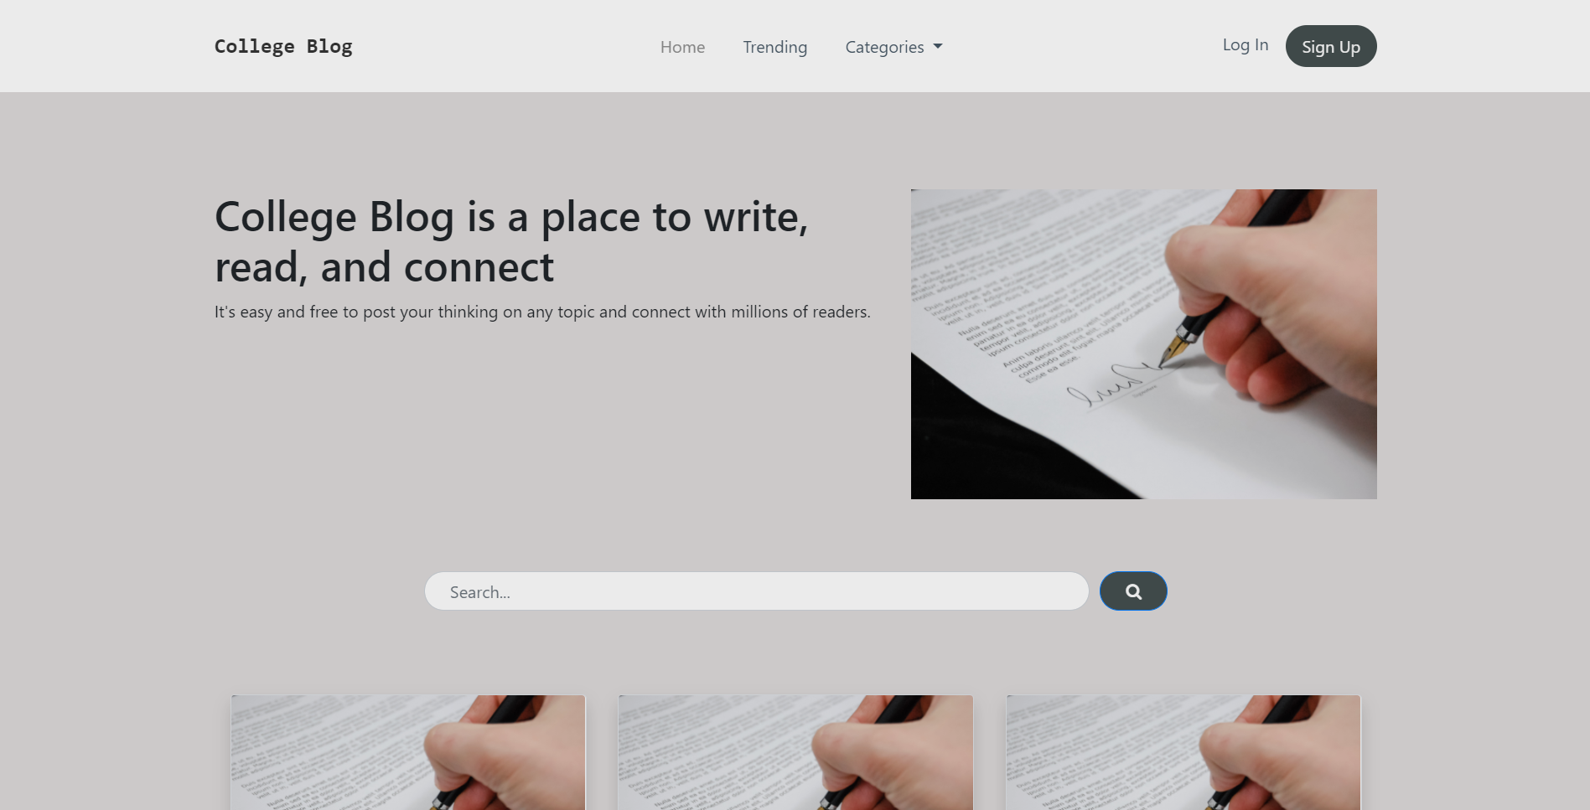

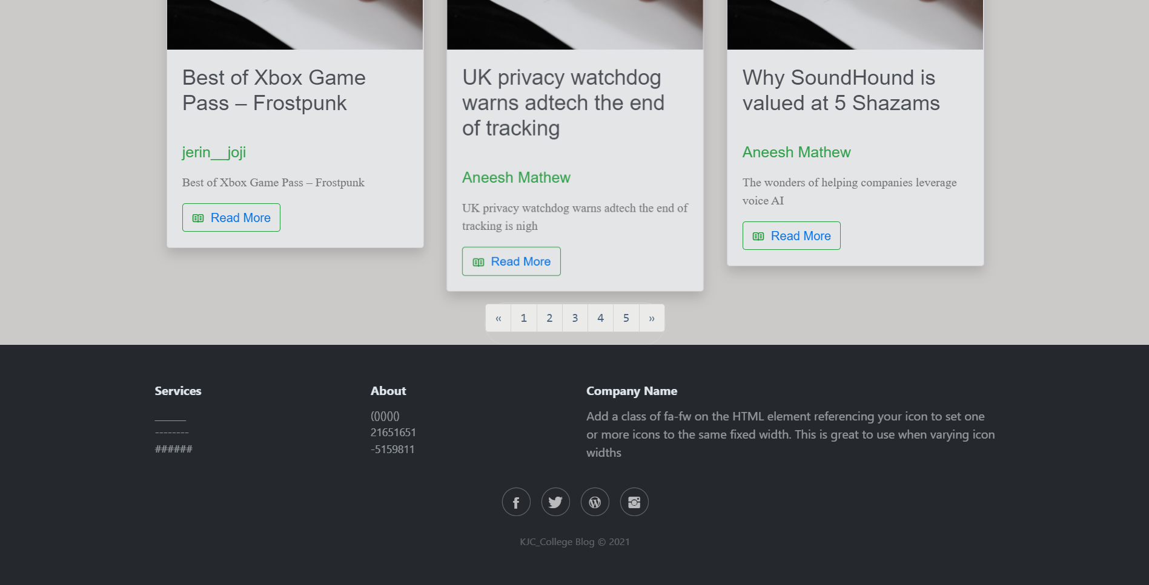

The blogs which are available to the user can be seen by the user and can also be searched by the user but cannot be read until and unless the user has an account and logs in into it.

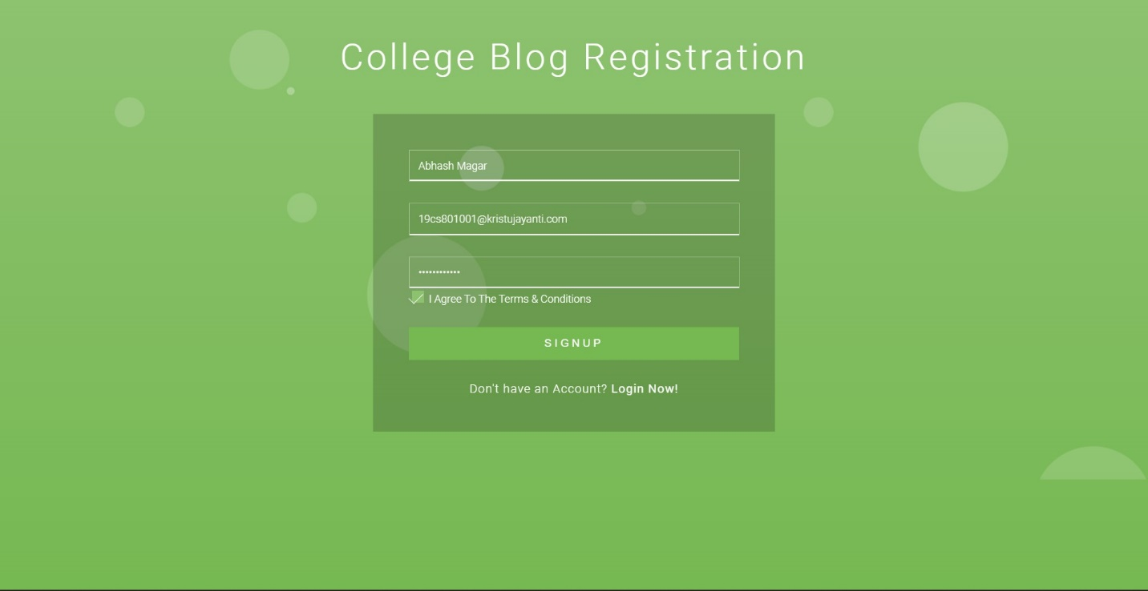

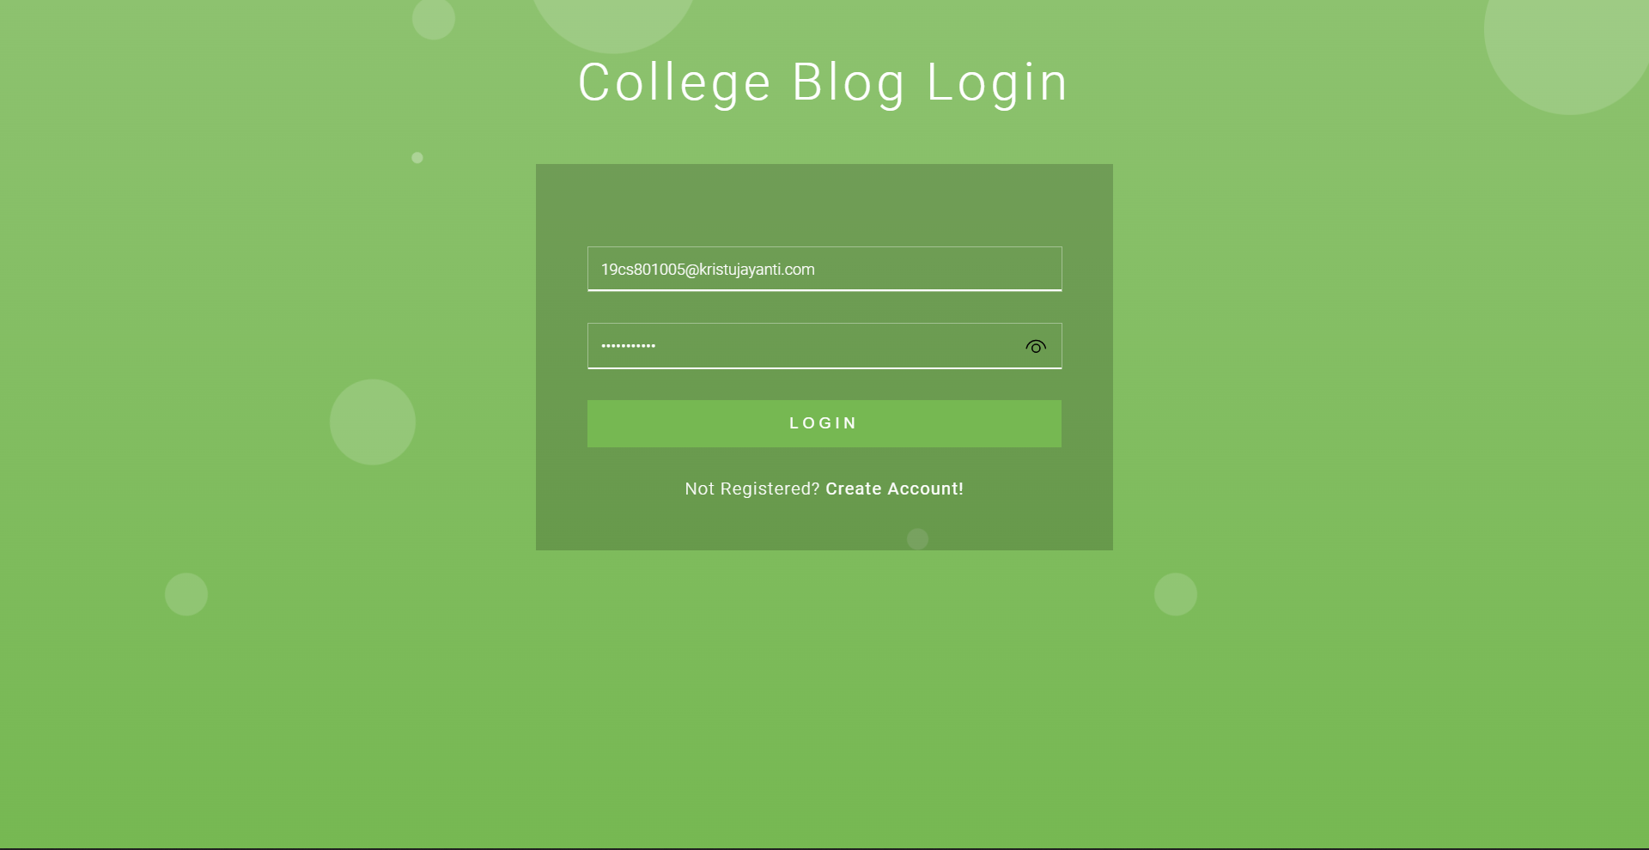

After the user logs into the the user will be able to read the blogs.

The user can also click on any blog and read more details of the blog.

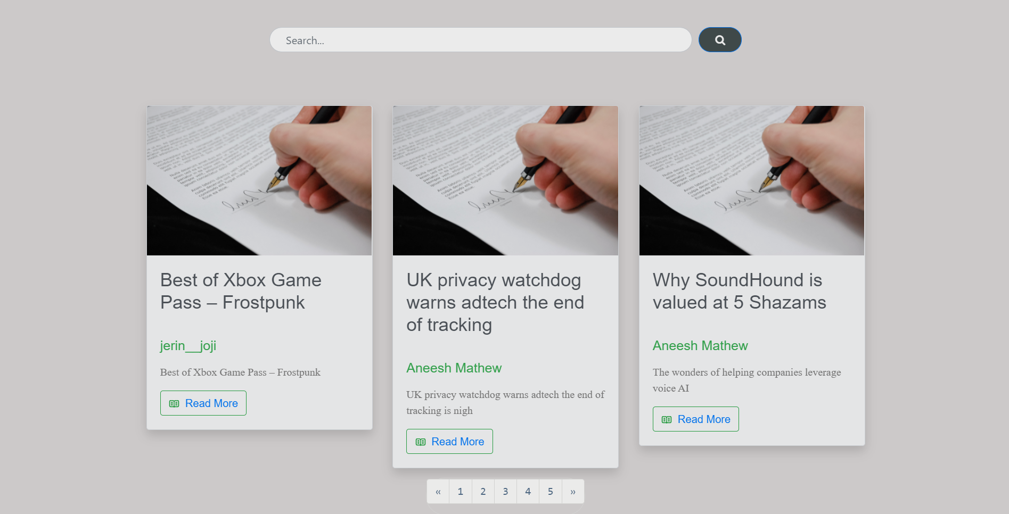

If the user likes the blog, he/she can like that blog. The user can also add comment to the blog.

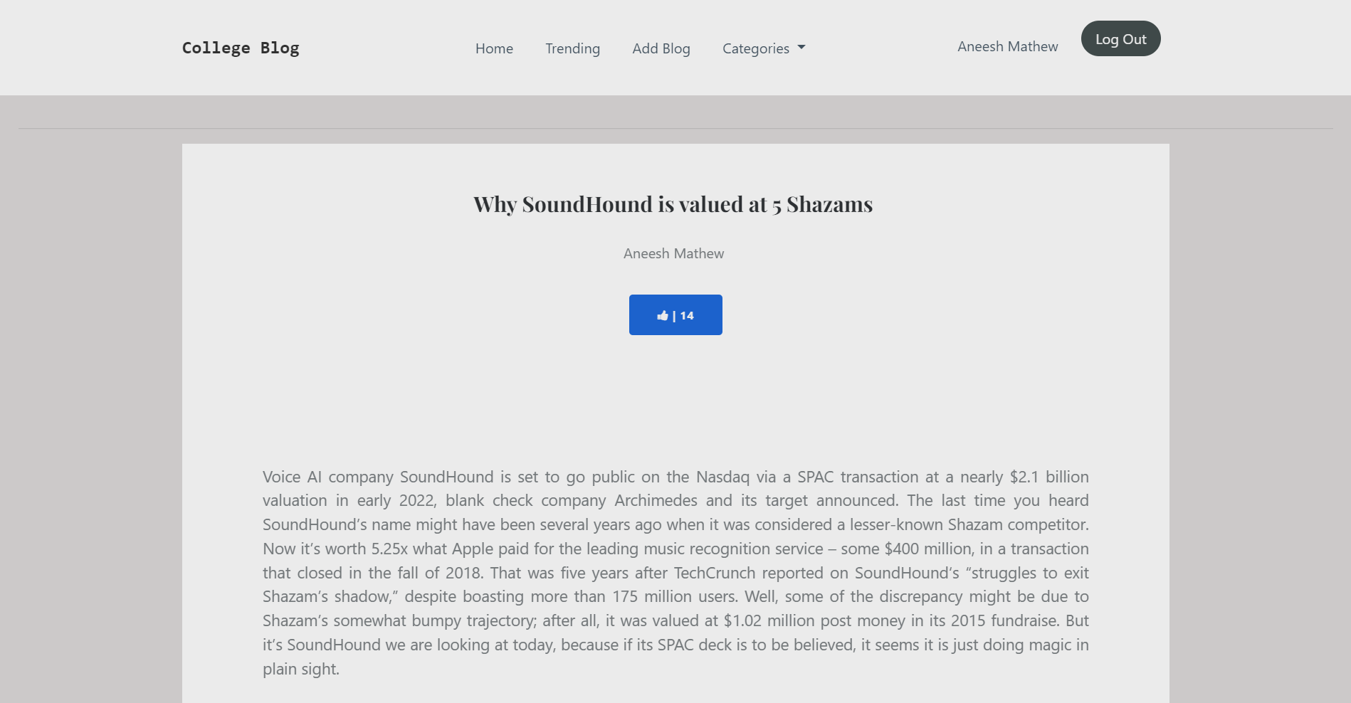

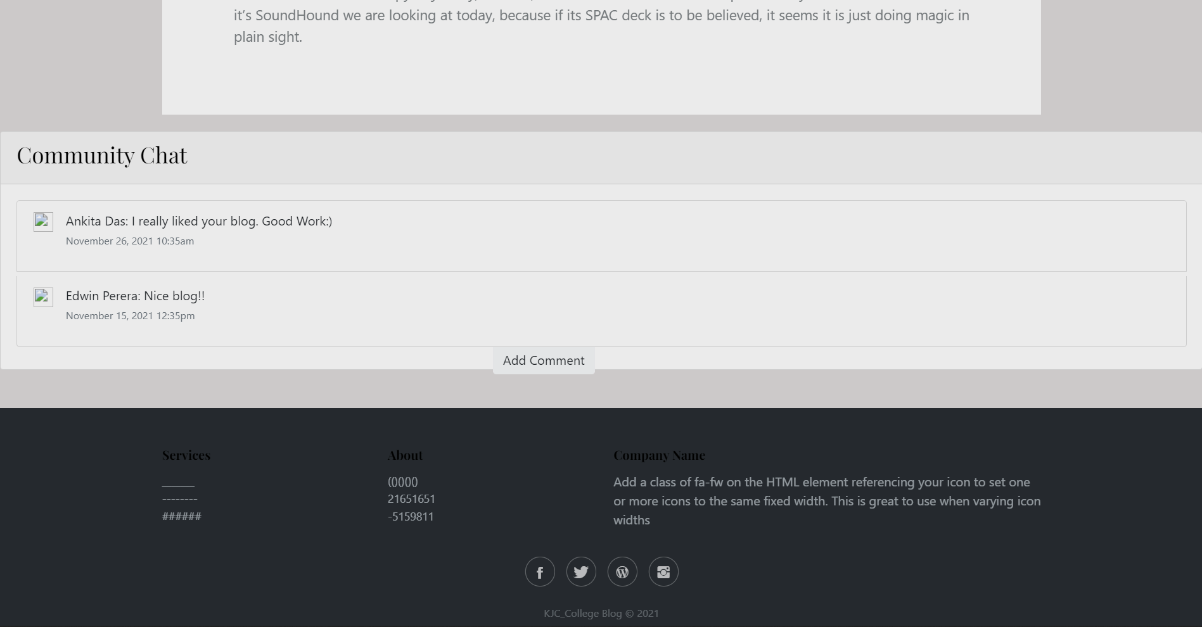

If the user wants to write his own blog he can do so by clicking the Add New Blog in header. The user has to add title, content, references and a small description. And submit.

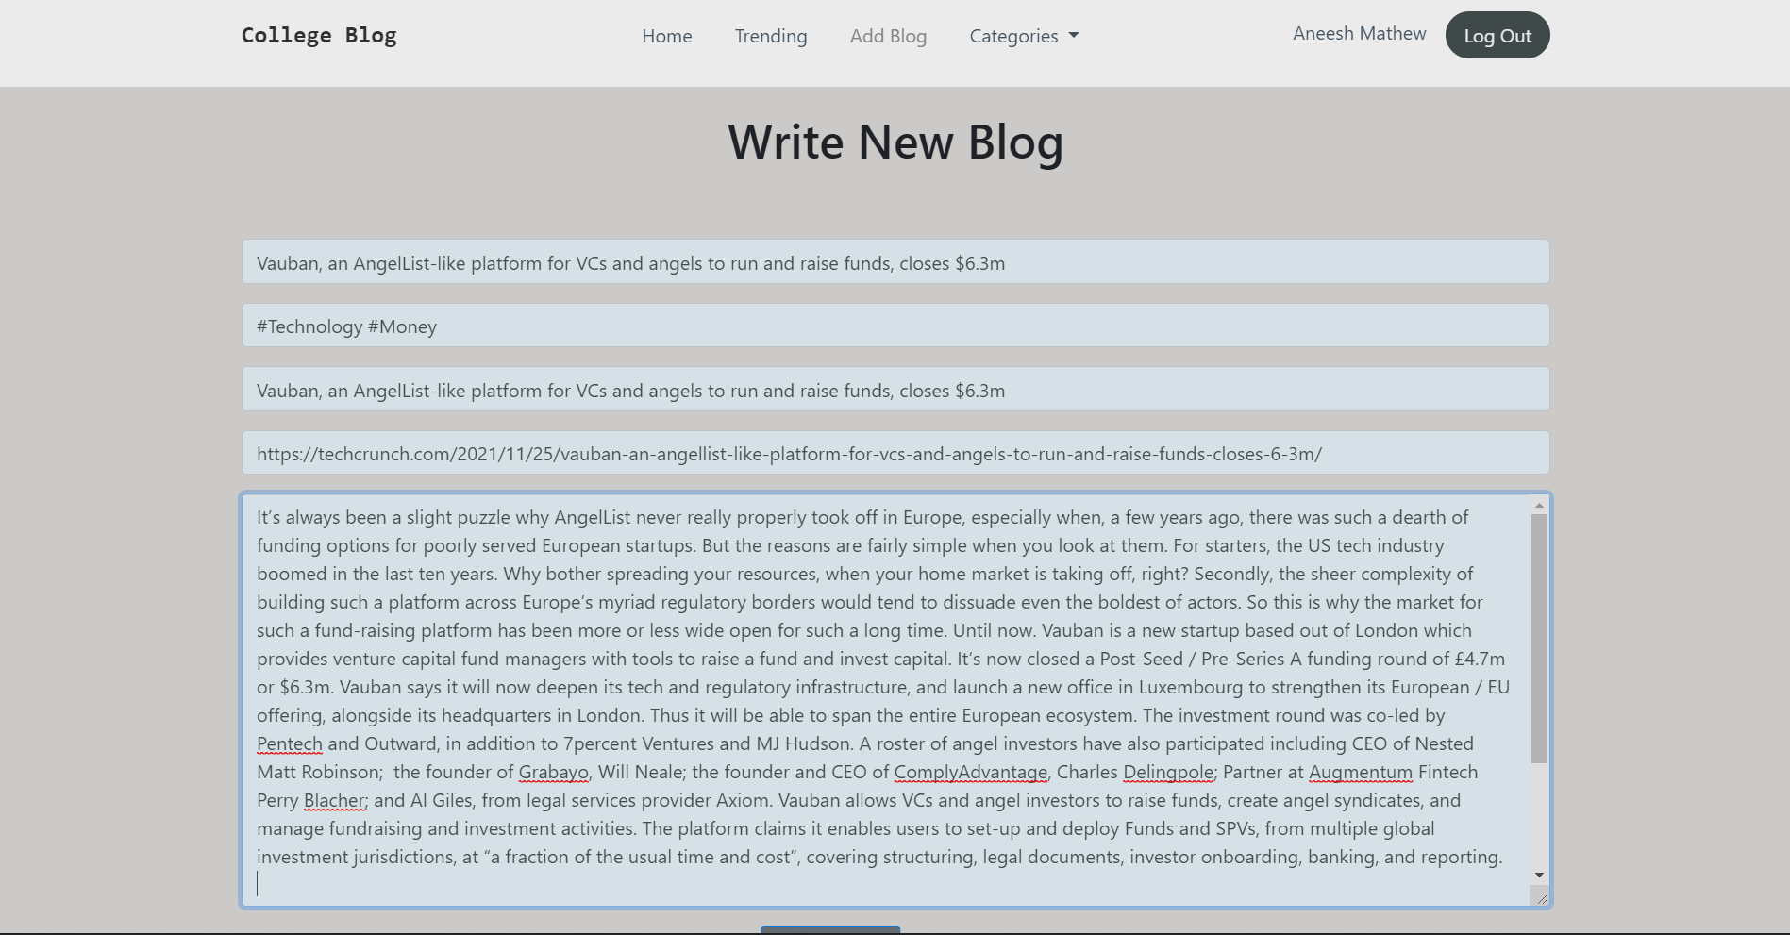

Finally, the user can logout of the system when done. It will return to the homepage.

**Screen Shot**

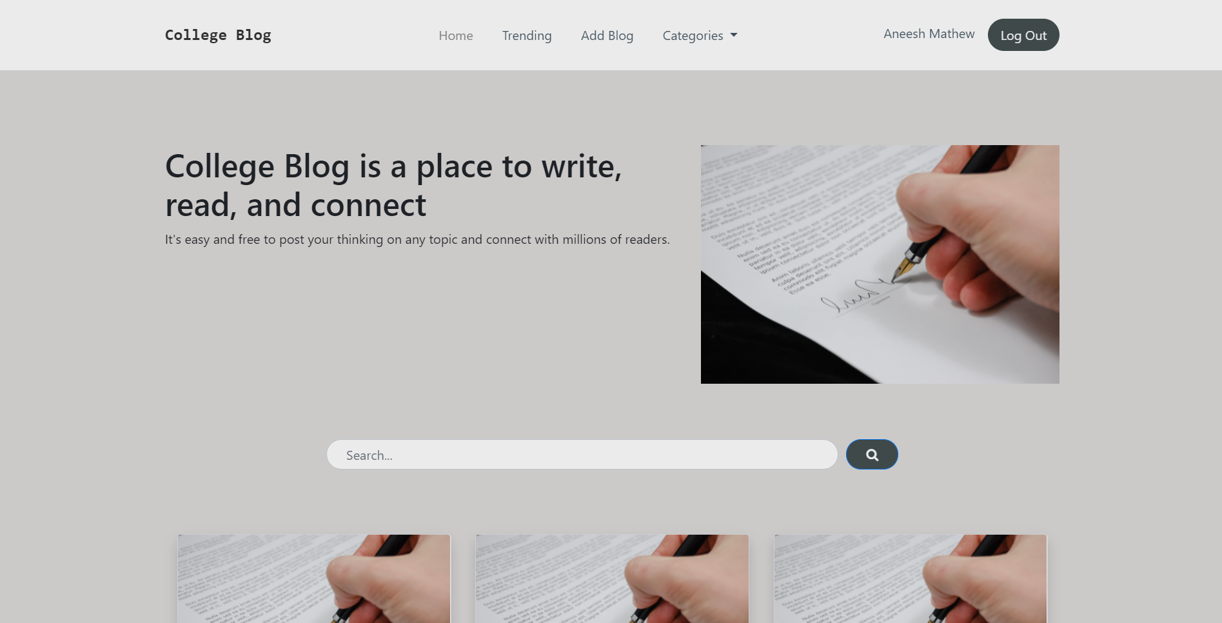

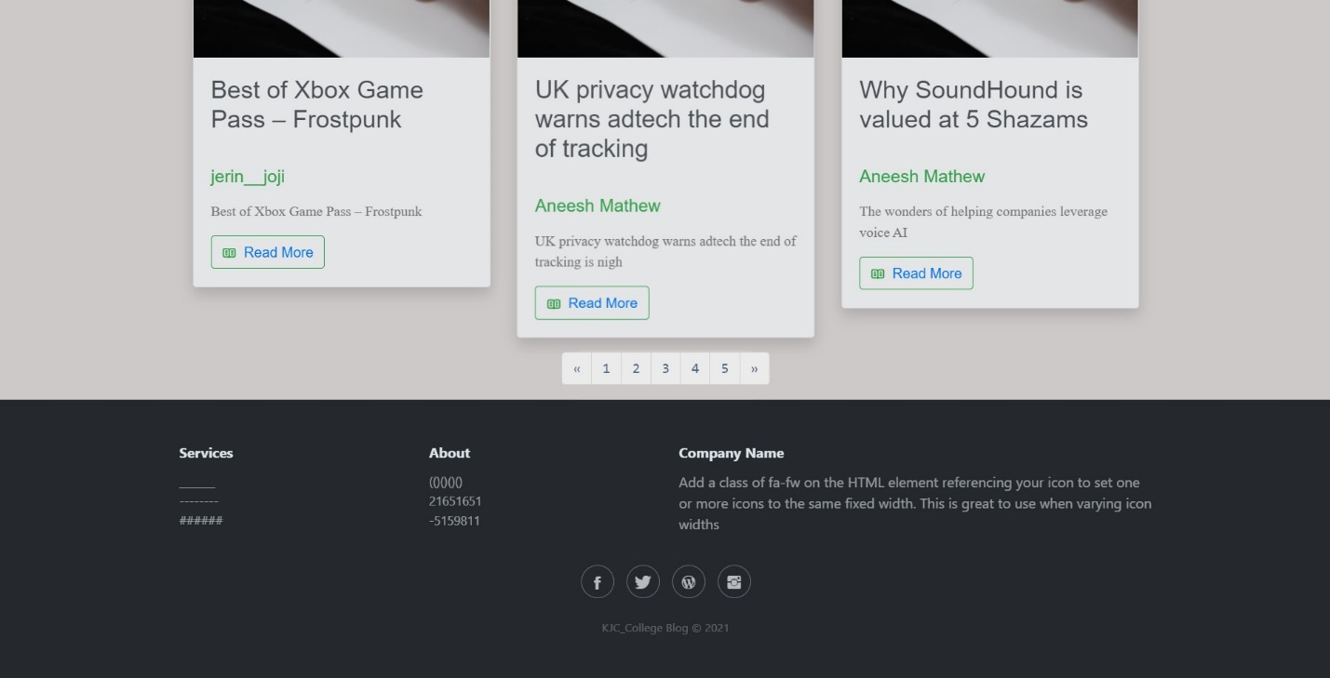



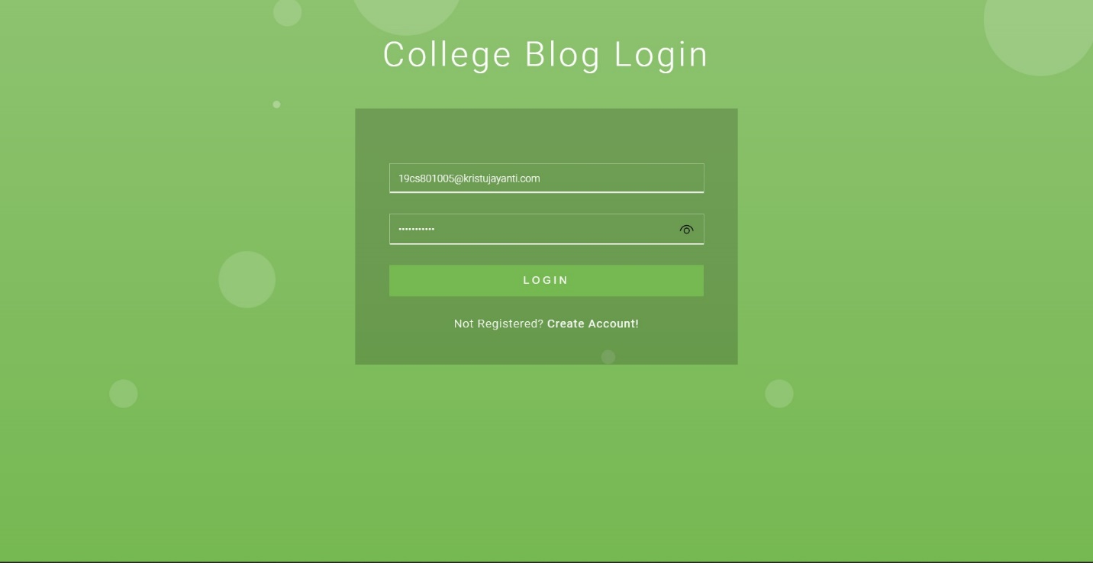

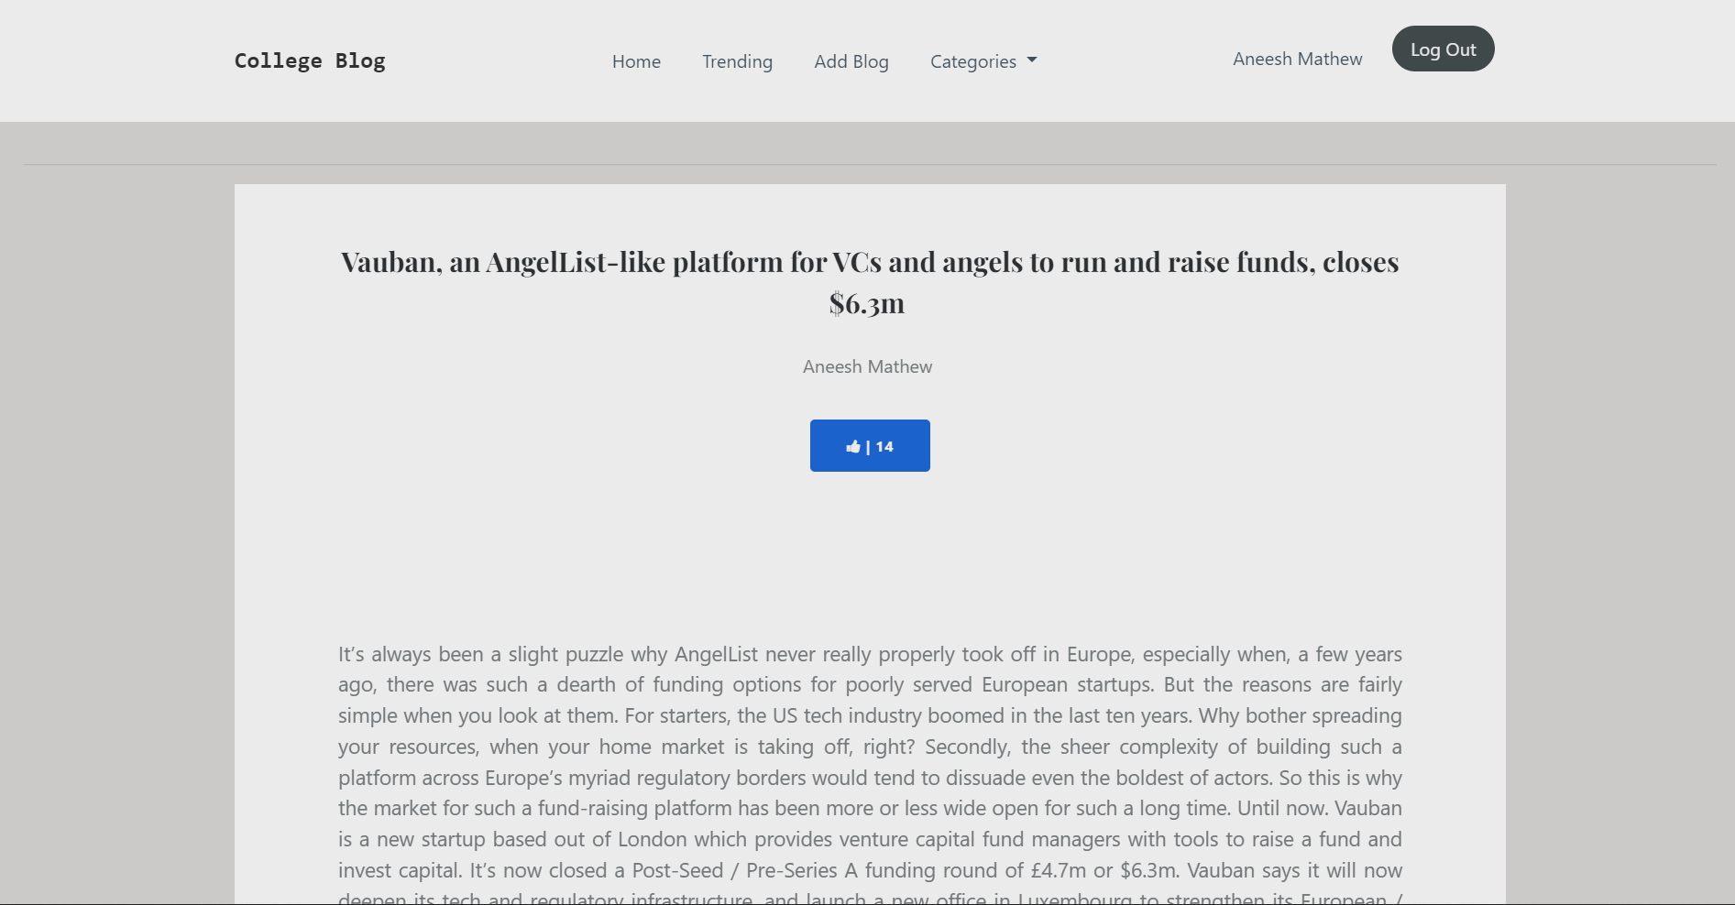

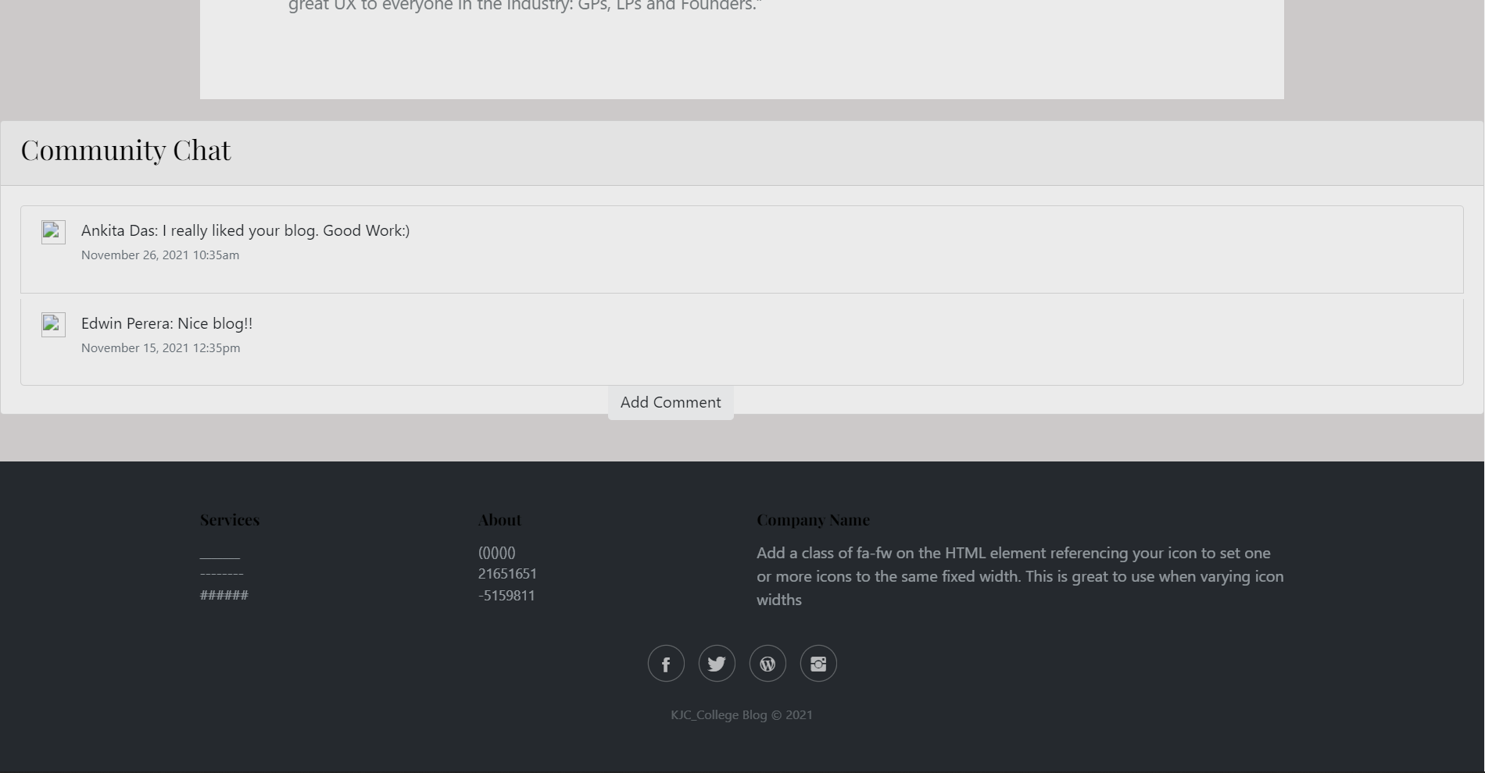

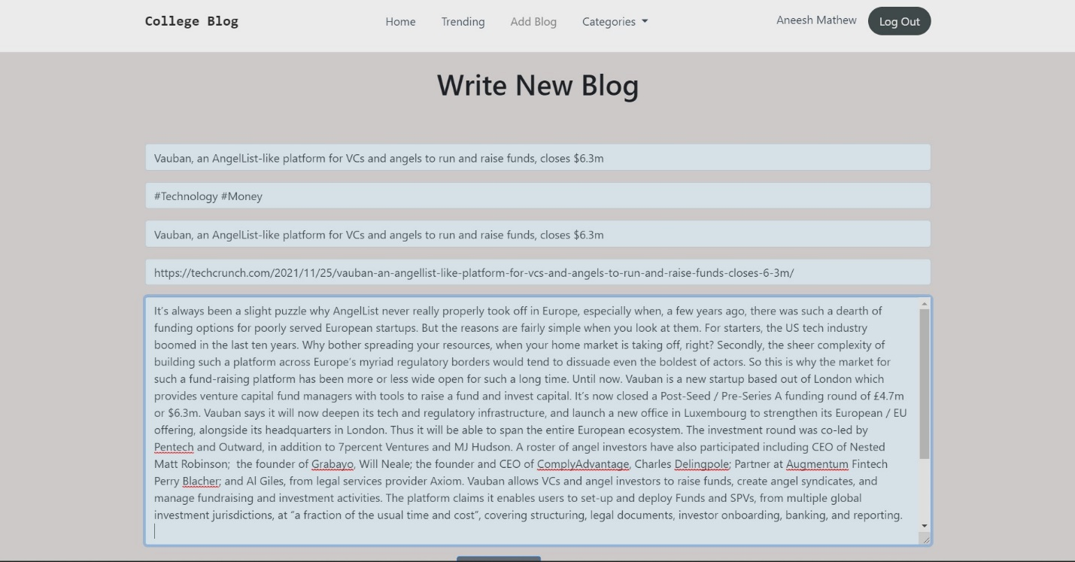

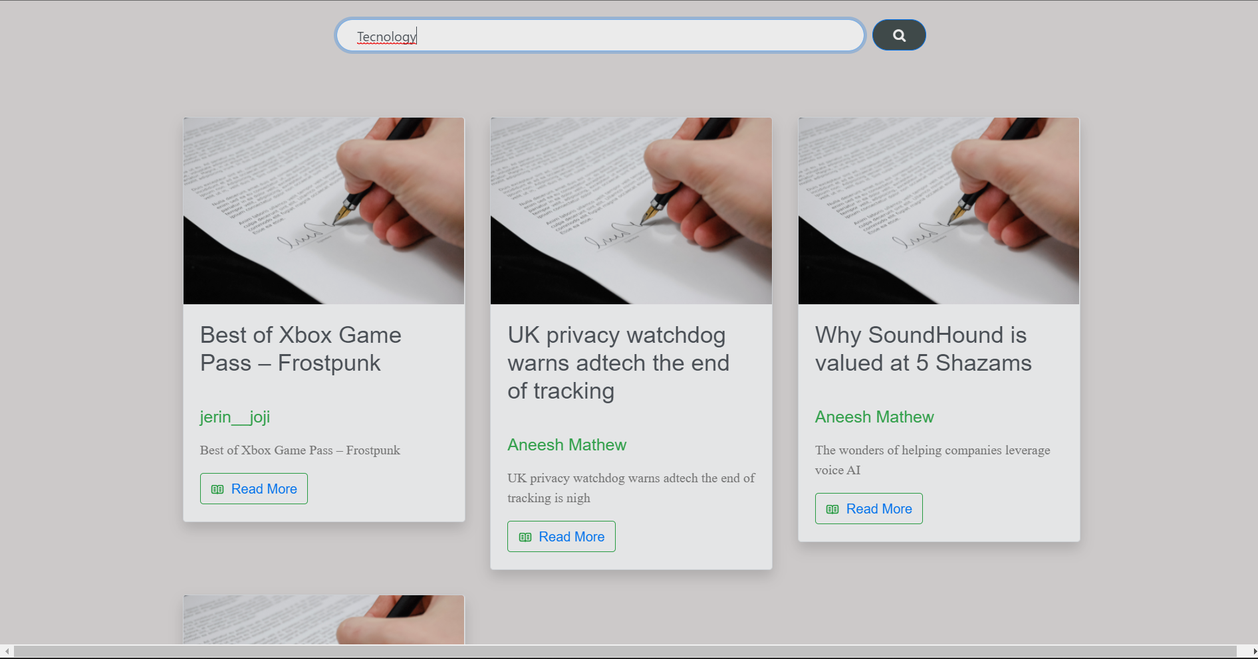

**Conclusion**

In a world where new thoughts and ideas are there in every youngsters mind, we wanted to give them a platform where they can express their thoughts, research and ideas and have opinions from others. By this, we believe that youngsters today can learn to share and receive new knowledge. We also believe that it will increase the motivation for reading and writing and showcase the young minds accomplishments, talents, ideas etc.

This project helped us in understanding the creation of an interactive web page and working with Flask, React and MongoDB project. During the course of this project, we have come across the wide variety of problems and difficulties. We have learned the appropriate intricate working behind the NoSQL project.

All possible error in the program have been eliminated. Necessary validation techniques have been used and normal, abnormal and extreme data was used to test the system. However, doing this project has been a good boost to our confidence as a future IT member.

**Bibliography**

* **Books**
  + Mastering Flask Web Development - Second Edition - Jack Stouffer Daniel Gaspar
  + Learning React: Functional Web Development with React and Redux – Alex Banks
  + The Definitive Guide to MongoDB – Peter Membrey
* **Wesite**
  + MongoDB Documentation - <https://docs.mongodb.com/>
  + Flask User’s Guides - https://flask.palletsprojects.com/en/2.0.x/#user-s-guide